University of Petra
Faculty of Information Technology
Department of Business Intelligence and Data Analysis


Graduation Project Report

Superstore Analytics:
Insights into Customer Behavior
A combined Business Intelligence, Forecasting, and Machine-Learning Study
Prepared by  Hamzeh Alhindawi  Hadeel Almasri | Supervised by  Dr. Ayman Mansour

Submitted: May 5, 2026
Academic Year 2025 / 2026

Abstract
In an era where every commercial decision can be guided by evidence, the ability to convert raw transaction logs into actionable knowledge has become a defining competitive advantage for retailers. This graduation project, titled "Superstore Analytics: Insights into Customer Behavior," investigates how Business Intelligence (BI), classical statistics, and Machine Learning (ML) techniques can be combined to uncover hidden patterns, evaluate operational performance, and predict future demand inside a real-world retail dataset. The dataset under study is the Superstore retail dataset, openly distributed on Kaggle, which records four years of transactions across the United States.
The work follows a structured analytical pipeline composed of five phases. Phase one inspects and cleans the raw dataset using Python and pandas, resolving issues such as duplicate rows, inconsistent date formats, currency symbols inside numeric columns, mixed-case categorical labels, missing entries, and extreme outliers. Phase two performs an exploratory data analysis (EDA) that produces bar charts, pie charts, line plots, scatter plots, and a correlation heatmap describing the structure of sales and profit. Phase three introduces predictive analytics: a Prophet time-series model is trained on monthly aggregated sales to forecast the following twelve months, and a Recency-Frequency-Monetary (RFM) segmentation classifies customers into actionable behavioral groups. Phase four trains a supervised classification model that predicts whether a given order line will be profitable, evaluating its quality with a confusion matrix and standard performance metrics. Phase five complements the Python work with a Power BI dashboard and a RapidMiner workflow.
The empirical results show that Office Supplies dominates order volume while Technology yields the highest absolute profit, that the West and East regions account for almost two-thirds of total revenue, and that profit is strongly eroded once discounts exceed twenty percent. The Tables, Bookcases, and Supplies sub-categories are confirmed as loss-making and require immediate pricing or product-mix review. Yearly growth is positive but uneven, with 2017 achieving the largest revenue uplift of approximately 88 percent over 2016. The Prophet model forecasts continued upward growth into 2018 with a clear seasonal peak in the fourth quarter. RFM analysis identifies 207 Champions and 60 Lost Customers among 793 unique buyers. The Random Forest classifier achieves an accuracy of 94.4 percent and an ROC-AUC of 0.984, with the Discount feature emerging as by far the most important predictor of profitability.
The project demonstrates that combining open-source analytics tools (Python, scikit-learn, Prophet) with enterprise platforms (Power BI, RapidMiner) produces a complete, end-to-end decision-support system. Beyond its descriptive value, the report provides concrete managerial recommendations, including discount-policy reform, regional intervention plans, customer-retention strategies driven by RFM tiers, and a real-time profitability classifier that can flag risky orders before they are confirmed.

Keywords: Business Intelligence, Data Analytics, Customer Behavior, Sales Forecasting, RFM Segmentation, Confusion Matrix, Random Forest, Prophet, Power BI, RapidMiner, Python, Retail Analytics.

Acknowledgments
We would like to express our sincere gratitude to everyone who contributed, directly or indirectly, to the completion of this graduation project. First and foremost, we thank Almighty God for granting us the patience, strength, and clarity required to take this work from a dirty CSV file all the way to a polished analytical report.
Our deepest appreciation goes to our supervisor, Dr. Ayman Mansour, whose insightful guidance, constructive feedback, and continuous encouragement shaped every chapter of this report. His expertise in data analytics, his patient explanations of statistical concepts, and his willingness to challenge our assumptions pushed the work to a much higher standard than we could have reached on our own.
We are also grateful to the academic staff of the Department of Business Intelligence and Data Analysis at the University of Petra for the courses and laboratory sessions that built the technical foundation on which this project rests. The training we received in statistics, databases, machine learning, and visualization was indispensable. Special recognition is due to the lab technicians and IT staff who maintained the workstations on which the analyses were performed.
We extend our heartfelt thanks to our families, who supported us emotionally and practically throughout the academic year. Their belief in our abilities was a constant source of motivation during the long nights spent debugging code, refining charts, and rewriting paragraphs. Finally, we thank our colleagues and friends, whose discussions, suggestions, and quiet companionship made this journey not only successful but genuinely enjoyable.

Hamzeh Alhindawi
Hadeel Almasri
May, 2026

Table of Contents
Abstract 2
Acknowledgments 4
Table of Contents 5
List of Figures 10
List of Tables 12
Chapter 1: Introduction 13
1.1 Background and Motivation 13
1.2 Problem Statement 13
1.3 Project Objectives 14
1.4 Scope of the Project 15
1.5 Significance of the Study 15
1.6 Report Organization 15
Chapter 2: Literature Review 17
2.1 Business Intelligence in Retail 17
2.2 Customer Behavior Analytics 17
2.3 The RFM Framework 18
2.4 Time-Series Forecasting and Prophet 18
2.5 Classification Models and Confusion Matrix 18
2.6 Visualization and Dashboard Design 19
2.7 Related Studies on the Superstore Dataset 20
Chapter 3: Methodology and Tools 21
3.1 Analytical Pipeline Overview 21
3.2 Tools and Technologies 21
3.2.1 Python and the Scientific Stack 21
3.2.2 Microsoft Power BI 22
3.2.3 RapidMiner Studio 22
3.3 Workflow Diagram 22
3.4 Reproducibility and Version Control 22
3.5 Quality Assurance 23
Chapter 4: Dataset Description 24
4.1 Source of the Dataset 24
4.2 Dataset Size and Coverage 24
4.3 Schema and Column Roles 25
4.4 Categorical Cardinality 26
4.5 Numeric Distributions 26
4.6 Data Types and Their Implications 27
4.7 Engineered Target for Classification 27
4.8 Ethical Considerations and Data Privacy 27
Chapter 5: Data Preparation and Cleaning 28
5.1 Data-Quality Issues Identified 28
5.2 Cleaning Pipeline in Python 28
5.2.1 Loading the Raw Dataset 28
5.2.2 Removing Duplicates 29
5.2.3 Multi-Format Date Parsing 29
5.2.4 Cleaning the Sales Column 29
5.2.5 Standardizing Categorical Labels 30
5.2.6 Handling Missing Values 30
5.2.7 Removing Outliers 30
5.3 Pipeline Outcome 31
Chapter 6: Exploratory Data Analysis (EDA) 33
6.1 Sales and Profit by Category 33
6.2 Sales and Profit by Region 34
6.3 Monthly Sales Trend by Year 35
6.4 Profit by Sub-Category 36
6.5 Customer Segment Analysis 37
6.6 Discount versus Profit 38
6.7 Yearly Sales and Profit Growth 39
6.8 Correlation Heatmap 40
Chapter 7: Forecasting and Customer Segmentation 42
7.1 Sales Forecasting with Prophet 42
7.1.1 Data Preparation for Prophet 42
7.1.2 Training the Model 42
7.1.3 Generating the Forecast 43
7.1.4 Decomposing Trend and Seasonality 43
7.2 Profit Margin Analysis 44
7.3 Shipping Duration Analysis 45
7.4 RFM Customer Segmentation 46
Chapter 8: Machine-Learning Classification of Profitability 49
8.1 Problem Definition 49
8.2 Feature Set 49
8.3 Preprocessing and Train / Test Split 50
8.4 Models Compared 50
8.5 Confusion Matrix 50
8.5.1 Reading the Four Cells 51
8.5.2 Performance Metrics Derived from the Matrix 52
8.5.3 What These Numbers Tell Us 52
8.6 Model Comparison 53
8.7 Feature Importance 54
8.8 ROC Curves 55
8.9 Limitations and Future Work 56
Chapter 9: Power BI Interactive Dashboard 57
9.1 Data Model and Measures 57
9.2 Page 1 — Executive Overview 57
9.3 Page 2 — Regional and Segment View 58
9.4 Page 3 — Profitability and Discount Analysis 59
9.5 Lessons Learned in Power BI 60
Chapter 10: RapidMiner Workflow 61
10.1 Process Design 61
10.2 Visual Outputs 61
10.3 Comparison Across the Three Tools 66
Chapter 11: Results and Discussion 68
11.1 Headline Indicators 68
11.2 Discussion of Objectives 69
11.2.1 Cleaning and Preparation 69
11.2.2 Exploratory Analysis 69
11.2.3 Discount Diagnosis 69
11.2.4 Forecasting 69
11.2.5 Customer Segmentation 69
11.2.6 Profitability Classification 70
11.2.7 Power BI and RapidMiner Integration 70
11.2.8 Consolidation into a Report 70
11.3 Triangulation Across Methods 70
11.4 Comparison with Initial Expectations 70
11.5 Limitations 70
Chapter 12: Conclusion and Recommendations 72
12.1 Conclusion 72
12.2 Recommendations to the Retailer 72
12.2.1 Pricing and Promotion Reform 72
12.2.2 Customer Strategy 73
12.2.3 Operational Excellence 73
12.2.4 Analytics Capability 73
12.3 Future Work 73
References 75
Appendix A: Full Cleaning Pipeline 77
A.1 Imports and Loading 77
A.2 Diagnostic Inspection 77
A.3 Fix 1 — Remove Duplicates 77
A.4 Fix 2 — Multi-Format Date Parsing 77
A.5 Fix 3 — Clean Sales Column 78
A.6 Fix 4 — Standardize Categorical Labels 78
A.7 Fix 5 — Missing Values 78
A.8 Fix 6 — Outlier Removal 78
Appendix B: EDA and Forecasting Code 79
B.1 Setup 79
B.2 Sales and Profit by Category 79
B.3 Profit by Sub-Category 79
B.4 Discount versus Profit 79
B.5 Correlation Heatmap 79
B.6 Prophet Forecast 80
B.7 RFM Segmentation 80
Appendix C: Classification Code 81
C.1 Imports 81
C.2 Data Loading and Preparation 81
C.3 Logistic Regression Pipeline 81
C.4 Random Forest 81
C.5 Confusion Matrix and Metrics 82
C.6 Confusion-Matrix Visualization 82
Appendix D: Glossary 83

List of Figures
This report includes 33 figures distributed across the analytical chapters. The Python figures (Chapters 6 to 8) were generated using Matplotlib, Seaborn, scikit-learn, and Prophet inside Jupyter notebooks. The Power BI figures (Chapter 9) were exported from an interactive dashboard, while the RapidMiner figures (Chapter 10) were produced from a no-code analytical workflow.

# | Figure Title | Source / Tool
3.1 | End-to-end project workflow diagram | Custom diagram (Matplotlib)
5.1 | Console output of the cleaning pipeline | Python
6.1 | Sales and profit by category | Matplotlib
6.2 | Sales and profit by region | Matplotlib
6.3 | Monthly sales trend by year | Matplotlib
6.4 | Profit by sub-category | Matplotlib
6.5 | Customer segment analysis | Matplotlib
6.6 | Discount versus profit | Matplotlib
6.7 | Yearly sales and profit growth | Matplotlib
6.8 | Correlation heatmap (high-resolution) | Seaborn
7.1 | 12-month sales forecast | Prophet
7.2 | Forecast components decomposition | Prophet
7.3 | Profit margin analysis | Matplotlib
7.4 | Shipping duration analysis | Matplotlib
7.5 | RFM customer segmentation | Matplotlib
8.1 | Confusion matrix — profitability classification | scikit-learn
8.2 | Classification model performance comparison | scikit-learn
8.3 | Feature importance — Random Forest | scikit-learn
8.4 | ROC curves | scikit-learn
9.1 | Power BI executive overview | Power BI
9.2 | Power BI regional & segment view | Power BI
9.3 | Power BI profitability analysis | Power BI
10.1 | RapidMiner main process | RapidMiner
10.2 | RapidMiner aggregated category breakdown | RapidMiner
10.3 | RapidMiner regional analysis | RapidMiner
10.4 | RapidMiner segment-level pivot | RapidMiner
10.5 | RapidMiner sub-category profit ranking | RapidMiner
10.6 | RapidMiner monthly trend | RapidMiner
10.7 | RapidMiner discount versus profit | RapidMiner
10.8 | RapidMiner shipping mode distribution | RapidMiner
10.9 | RapidMiner correlation visualization | RapidMiner
10.10 | RapidMiner consolidated KPI panel | RapidMiner
10.11 | RapidMiner auxiliary visualization | RapidMiner

List of Tables
The report contains 12 numbered tables that summarize structural information, data-quality outcomes, statistics, and managerial recommendations. Each table is referenced from the body text where it appears.

# | Table Title | Section
4.1 | Schema of the Superstore dataset | Chapter 4
4.2 | Categorical-column cardinality and dominant values | Chapter 4
5.1 | Cleaning operations and resulting row counts | Chapter 5
5.2 | Numeric column statistics (post-cleaning) | Chapter 5
7.1 | Suggested marketing actions per RFM segment | Chapter 7
8.1 | Selected features and types for the classifier | Chapter 8
8.2 | Confusion-matrix interpretation | Chapter 8
8.3 | Classifier performance metrics | Chapter 8
8.4 | Feature importance ranking | Chapter 8
10.1 | Tool comparison: Python vs Power BI vs RapidMiner | Chapter 10
11.1 | Headline indicators of the project | Chapter 11
C.1 | Glossary of acronyms and concepts | Appendix C

Chapter 1: Introduction

1.1 Background and Motivation
Modern retail organizations operate in a hyper-competitive environment where customer expectations are rising, profit margins are tightening, and the cost of poor decisions has never been higher. Every transaction recorded by a point-of-sale system or e-commerce platform produces a small piece of evidence that, when aggregated across millions of orders, becomes a strategic asset. The challenge for retailers is not the lack of data but the absence of structured methods to translate that data into clear business actions. This translation gap is precisely the space occupied by Business Intelligence (BI) and applied data science.
Business Intelligence refers to the technologies, processes, and best practices that transform raw operational data into reports, dashboards, and predictive models that support decision-making at every level of an organization. Tools such as Power BI, Tableau, RapidMiner, and Python have democratized access to advanced analytics, allowing even mid-sized retailers to perform analyses that were once reserved for large corporations with specialized analytics teams. The Superstore dataset used in this project is a canonical retail dataset that mirrors the kinds of records typical of any modern retailer: orders, products, customers, geographies, dates, sales values, profits, and shipment information. Working with such a dataset enables the project to demonstrate methods that transfer directly to real industry settings.
Within this context, the present graduation project applies a complete analytical pipeline to the Superstore dataset, beginning with raw data and ending with predictive insights, a profitability classifier, and managerial recommendations. The work spans descriptive analytics (what happened), diagnostic analytics (why it happened), predictive analytics (what will happen next), and prescriptive analytics (what should be done about it). By integrating Python, Power BI, and RapidMiner, the project also illustrates the complementary strengths of code-driven and visual no-code approaches.

1.2 Problem Statement
Retailers possess vast volumes of transactional data, yet many continue to make pricing, inventory, marketing, and customer-service decisions based on intuition rather than evidence. The Superstore dataset, like many real retail datasets, contains hidden but commercially important patterns that remain invisible when looked at in spreadsheet form alone. Specifically, the following questions are difficult to answer without dedicated analytical work:
- Which categories, sub-categories, regions, and customer segments contribute the most and least to revenue and profitability?
- Are aggressive discount levels eroding profits more than they generate additional sales?
- Is the business growing year over year, and what does the future trajectory of monthly sales look like?
- Which customers are most valuable, which are at risk of leaving, and which have already churned?
- What is the operational performance of the shipping function, and is it consistent across regions and ship modes?
- Can we predict, before an order is confirmed, whether it will be profitable, so that managers can intervene on risky orders in time?
The core problem addressed by this project is therefore not a lack of data, but the absence of a coherent analytical framework that converts raw Superstore records into prioritized, defensible business decisions. Without such a framework, decision-makers risk continuing unprofitable promotions, neglecting valuable customer segments, and misallocating logistics or marketing budgets.

1.3 Project Objectives
The project pursues a set of clearly defined objectives, each of which produces a measurable analytical artefact (a chart, a model, a table, or a recommendation):
- Clean and prepare the raw Superstore dataset by removing duplicates, standardizing date formats, harmonizing categorical labels, and handling missing values and outliers.
- Produce a comprehensive exploratory data analysis (EDA) describing sales and profit by category, sub-category, region, customer segment, ship mode, and time.
- Quantify the relationship between discount levels and profitability and identify the threshold beyond which discounts destroy value.
- Build a sales forecasting model using Facebook Prophet that predicts monthly sales for twelve months ahead with calibrated confidence intervals.
- Segment customers using the Recency, Frequency, Monetary (RFM) framework and translate the segments into concrete retention and reactivation strategies.
- Train a supervised classification model that predicts the profitability of an order line, evaluate it through a confusion matrix, and quantify its performance with accuracy, precision, recall, F1-score, and ROC-AUC.
- Complement the Python analyses with a Power BI dashboard for interactive exploration and a RapidMiner workflow that demonstrates the same analyses in a visual no-code environment.
- Consolidate every result into a structured graduation report that serves both as academic documentation and as a managerial briefing for an actual retailer.

1.4 Scope of the Project
The project is bounded by the data available in the cleaned Superstore dataset, which contains 8,708 transactions covering the period from 2014 to 2017 across the four U.S. regions of West, East, Central, and South. The geographic scope is limited to the United States, and the product scope is limited to office furniture, technology, and office supplies. Although the methods presented are transferable, claims about other countries, products, or time periods would require additional data and validation.
The analytical scope covers descriptive statistics, exploratory visualizations, time-series forecasting at monthly granularity, customer segmentation using the unsupervised RFM technique, and supervised binary classification with logistic regression and random-forest models. More advanced topics such as deep learning, recommender systems, market-basket analysis, customer-lifetime-value modeling, and pricing optimization are considered out of scope and are listed in the recommendations chapter as future-work directions.

1.5 Significance of the Study
This study has both academic and practical value. From an academic standpoint, it demonstrates the integration of three distinct analytical environments (Python, Power BI, RapidMiner) and four analytical paradigms (descriptive, diagnostic, predictive, prescriptive) on a single business problem, providing a template that future students of business intelligence can adapt to other datasets. It also illustrates how classical statistical thinking, modern machine-learning forecasting and classification, and visualization design come together inside one coherent project rather than appearing as isolated subjects on a syllabus.
From a practical standpoint, the analyses can be applied directly to retail operations. Retail managers reading this report will find concrete recommendations regarding which sub-categories to discontinue or reprice, which discount tiers should be capped, which regions deserve targeted investment, which customers should receive loyalty rewards, how monthly demand should be planned for the year ahead, and how a real-time profitability classifier can flag risky orders for managerial review. The report therefore moves beyond academic exercise toward a deliverable that resembles the kind of analytical white paper a junior analyst might present to a leadership team.

1.6 Report Organization
The remainder of this report is organized into eleven further chapters. Chapter 2 surveys the relevant literature on business intelligence, customer-behavior analytics, RFM segmentation, time-series forecasting, and classification metrics. Chapter 3 documents the methodology and the technologies adopted. Chapter 4 introduces the dataset in depth: source, schema, types, and structural statistics. Chapter 5 details the data-preparation pipeline, including the Python code used for each cleaning step. Chapter 6 presents the exploratory data analysis through eight thematic charts. Chapter 7 covers forecasting and customer segmentation. Chapter 8 introduces the machine-learning classification, the confusion matrix, and the performance metrics. Chapter 9 describes the Power BI dashboard, while Chapter 10 documents the RapidMiner workflow. Chapter 11 consolidates the results and discussion. Chapter 12 offers the conclusion, recommendations, and future-work directions, and the report ends with references and four appendices that contain the full Python code listings.

Chapter 2: Literature Review

2.1 Business Intelligence in Retail
Business Intelligence (BI) emerged in the late 1980s as a response to the proliferation of operational databases that produced more data than any human could read, let alone interpret. Early BI systems were simply reporting tools running over relational databases, but the field has since matured to encompass extract-transform-load (ETL) pipelines, data warehouses, multidimensional cubes, semantic models, dashboards, and advanced analytics. The retail sector was among the earliest adopters because of the natural granularity of point-of-sale transactions and the immediate financial impact of incremental insights into pricing, promotion, and inventory.
Contemporary BI in retail is increasingly self-service. Tools such as Microsoft Power BI, Tableau, and Qlik allow business analysts to build dashboards without writing SQL or learning a programming language. At the same time, the analytical depth of these tools has grown: Power BI now embeds DAX, Power Query (M language), AI insights, and integration with Python and R scripts. The combination of low entry barrier and high analytical ceiling has made BI a strategic backbone in retail organizations of all sizes, from family-owned stores to multinational chains.
The retail BI literature emphasizes a hierarchy of analytical maturity: descriptive analytics (what happened), diagnostic analytics (why it happened), predictive analytics (what will happen next), and prescriptive analytics (what should we do about it). Each rung adds value but also requires more sophisticated tooling and methodology. The Superstore project executes all four levels, providing a faithful illustration of how a retailer can move up the maturity ladder one analytical artefact at a time.

2.2 Customer Behavior Analytics
Customer behavior analytics studies the patterns of how customers interact with a business: when they buy, what they buy, how often, in what channels, and at what price points. The field is grounded in the marketing literature on customer lifetime value (CLV), share of wallet, and customer journey mapping. In retail specifically, the dominant methods include cohort analysis (comparing customers acquired in different periods), churn prediction (estimating the probability that a customer will stop buying), and segmentation (grouping customers by behavioural similarity).
Customer segmentation can be supervised, in which a target variable such as churn is predicted, or unsupervised, in which the model discovers groups without external labels. Unsupervised techniques range from simple thresholding heuristics to k-means clustering and hierarchical clustering. The most common heuristic in retail is the Recency-Frequency-Monetary (RFM) framework, originally introduced for direct mail marketing in the 1990s and still widely used because of its interpretability and minimal data requirements.

2.3 The RFM Framework
The RFM model summarizes each customer with three values: Recency (days since the customer last purchased), Frequency (number of orders within a chosen window), and Monetary value (total spend within the window). Each customer is scored on a quartile basis on each of the three dimensions and the three scores are combined into a single RFM score. Higher scores indicate more valuable customers. Although simple, RFM has repeatedly been shown to outperform sophisticated models on direct-marketing tasks because customer behavior is largely captured by these three signals.
In this project, the RFM analysis follows the standard quartile scoring procedure (1 to 4 on each dimension) and aggregates the three scores into a single composite that ranges from 3 to 12. Composite scores are then mapped to descriptive labels — Champions, Loyal Customers, Potential Loyalists, At Risk, and Lost Customers — that translate naturally into marketing actions. The advantage of RFM in a graduation context is that it is computationally light, easy to explain to non-technical stakeholders, and produces immediately actionable customer lists.

2.4 Time-Series Forecasting and Prophet
Forecasting future values of a time series is one of the oldest and most studied problems in statistics. Classical methods such as exponential smoothing, ARIMA (Autoregressive Integrated Moving Average), and SARIMA (Seasonal ARIMA) require careful manual specification of differencing orders and seasonal terms, which limits their practicality for non-experts. The Facebook (now Meta) Prophet library, released in 2017, addresses this gap by exposing a curve-fitting style API that decomposes the series into trend, seasonality (yearly, weekly, daily), and holiday effects, fitted with a Bayesian approach implemented in Stan.
Prophet is well suited to retail demand forecasting because monthly or daily sales typically exhibit strong yearly seasonality, holiday spikes, and gradual long-term trends, all of which Prophet can capture with little tuning. The library also produces calibrated uncertainty intervals (the yhat_lower and yhat_upper output columns) that are essential when planning inventory or staffing buffers. The current project uses Prophet on monthly Superstore sales to produce a 12-month forecast and decomposes the result into trend and yearly-seasonality components for managerial interpretation.

2.5 Classification Models and Confusion Matrix
Binary classification is the supervised-learning task of mapping a feature vector to one of two outcome labels. In retail, common binary problems include: will an order be profitable, will a customer churn, will a delivery be late, and will a card transaction be fraudulent. Two of the most established families of classifiers are the logistic regression (a parametric, linear-in-the-logit model that produces well-calibrated probabilities) and the random forest (a non-parametric ensemble of decision trees that captures non-linear feature interactions without manual feature engineering). Both families are used in this report and benchmarked side by side.
The standard tool for evaluating binary classifiers is the confusion matrix, a two-by-two table that contrasts the predicted class with the actual class. The four cells of the matrix correspond to the four outcomes a binary classifier can produce: True Positives (TP) are positive cases correctly predicted as positive; True Negatives (TN) are negative cases correctly predicted as negative; False Positives (FP) are negative cases incorrectly predicted as positive (a "Type I" error); and False Negatives (FN) are positive cases incorrectly predicted as negative (a "Type II" error). From the four counts the analyst derives the four standard headline metrics described below.
- Accuracy = (TP + TN) / (TP + TN + FP + FN). The fraction of all predictions that are correct. Easy to interpret but misleading on imbalanced datasets.
- Precision = TP / (TP + FP). Of the orders predicted as profitable, the share that really were. High precision means few false alarms.
- Recall = TP / (TP + FN). Of the truly profitable orders, the share the model recognized. High recall means few missed cases.
- F1-Score = 2 × Precision × Recall / (Precision + Recall). The harmonic mean of precision and recall. Useful when both are equally important.
In addition, the ROC curve plots the true positive rate against the false positive rate at every classification threshold, and its area (ROC-AUC) summarizes the model's discriminative power across all thresholds. An AUC of 0.5 corresponds to random guessing, while 1.0 corresponds to perfect classification. These five metrics — accuracy, precision, recall, F1-score, and ROC-AUC — are computed and reported for both classifiers in Chapter 8.

2.6 Visualization and Dashboard Design
Visualization theory builds on perceptual research showing that humans rapidly extract patterns from position, length, and color, but struggle with angle (pie chart slices) and three-dimensional projections. Effective dashboards therefore prioritize bar charts, line charts, and small multiples while reserving pie charts for cases with very few categories. Color should encode meaning (loss versus profit, growth versus decline) rather than decoration, and every chart should answer a single, clearly stated question.
The Superstore dashboards in this project follow these principles. Loss-making sub-categories are colored red against a backdrop of green profitable ones, the discount-impact chart uses a horizontal reference line at zero profit to make the threshold visually unmistakable, and the regional comparisons rely on length-based bar charts rather than colored maps. The overarching design philosophy is that a manager who has only thirty seconds with the dashboard should still leave with the key takeaway clearly remembered.

2.7 Related Studies on the Superstore Dataset
Because the Superstore dataset is openly distributed on Kaggle as a popular learning dataset, it has been the subject of countless tutorials, blog posts, and capstone projects. Most published work focuses on either dashboard design (Tableau and Power BI) or on a single analytical task such as classification of profitable orders. Few projects integrate cleaning, EDA, forecasting, segmentation, classification, and multi-tool dashboarding into one cohesive deliverable. This graduation project therefore positions itself as a comprehensive case study rather than a novel methodological contribution. The novelty lies not in the algorithms but in the breadth of integration and in the clarity of the managerial recommendations that follow from the analysis.

Chapter 3: Methodology and Tools

3.1 Analytical Pipeline Overview
The methodology adopted for this project follows the well-known CRISP-DM (Cross-Industry Standard Process for Data Mining) framework, adapted to the requirements of an academic deliverable. CRISP-DM organizes a data project into six iterative phases: business understanding, data understanding, data preparation, modeling, evaluation, and deployment. The Superstore project executes each phase, treating the final report as the deployment artefact in place of a production system.
In the business-understanding phase the project identified the key questions that retail decision-makers care about: where revenue and profit come from, where they are leaking, which customers should be retained, what the demand will look like next year, and whether the profitability of an order can be predicted before it is confirmed. In the data-understanding phase the team inspected the raw CSV file to learn about its size, columns, types, and quality issues. The data-preparation phase produced a clean dataset ready for analysis, and the modeling phase delivered the EDA charts, the Prophet forecast, the RFM segmentation, and the binary classification model. The evaluation phase consisted of cross-checking results across Python, Power BI, and RapidMiner to make sure the headline numbers agreed, and benchmarking the classifier with multiple metrics. Finally, the deployment phase produced the dashboards, the report, and the recommendations.

3.2 Tools and Technologies
Three main analytical environments were used in the project, each chosen for the strength it brings to a specific task. Together they cover the full spectrum from low-level coding to no-code dashboarding.

3.2.1 Python and the Scientific Stack
Python was selected as the primary tool for data preparation, exploratory analysis, forecasting, and machine learning because it provides a mature ecosystem of open-source libraries. Pandas was used for data loading, cleaning, grouping, and aggregation. NumPy supplied numerical primitives. Matplotlib and Seaborn produced the static charts embedded in this report. Prophet (the open-source time-series library released by Meta) was used for the 12-month forecast. scikit-learn was used to train and evaluate the logistic-regression and random-forest classifiers, and to compute the confusion matrix and the standard performance metrics. All Python work was conducted inside Jupyter notebooks running in JetBrains PyCharm, which ensured reproducibility and made it straightforward to attach the code listings to the appendices.

3.2.2 Microsoft Power BI
Power BI Desktop was used to design an interactive dashboard. The cleaned dataset was imported through Power Query, where additional transformations (currency formatting, calculated columns) were applied. DAX measures were authored to compute total sales, total profit, profit margin, and year-over-year growth. Visuals were arranged into a multi-page layout that lets a non-technical user filter by category, region, or year and immediately see the impact on key indicators. Power BI was preferred over alternatives such as Tableau or Looker because it integrates seamlessly with the Excel-style workflow that most retail managers are already familiar with, and because it is available at no cost on the desktop.

3.2.3 RapidMiner Studio
RapidMiner Studio is a visual data-science platform that lets analysts compose data pipelines by dragging and connecting operators on a canvas. The tool was used to demonstrate that the same analyses (aggregation, filtering, charting) can be performed without writing any code. A workflow was built that reads the cleaned CSV, performs categorical aggregations, and produces a series of charts that mirror the Python EDA. RapidMiner adds value by lowering the technical barrier for future users of the project who may not be comfortable with Python.

3.3 Workflow Diagram
The project workflow is illustrated below in textual form. It starts with the raw CSV produced from the original Superstore export and ends with the consolidated graduation report.

Raw_Superstore_Dataset.csv (9,994 rows, dirty)
↓ Data Cleaning (Python / pandas)
Clean_Superstore.csv (8,708 rows, validated)
↓ Three parallel analytical tracks
Python EDA + Prophet + RFM + Classification | Power BI Dashboard | RapidMiner Workflow
↓ Cross-validation and integration
Graduation Project Report (this document)

A consolidated visual representation of the same workflow is shown in Figure 3.1. The diagram highlights the three independent analytical tracks — Python, Power BI, and RapidMiner — that operate in parallel on the cleaned dataset before their findings are cross-validated and integrated into the final report.
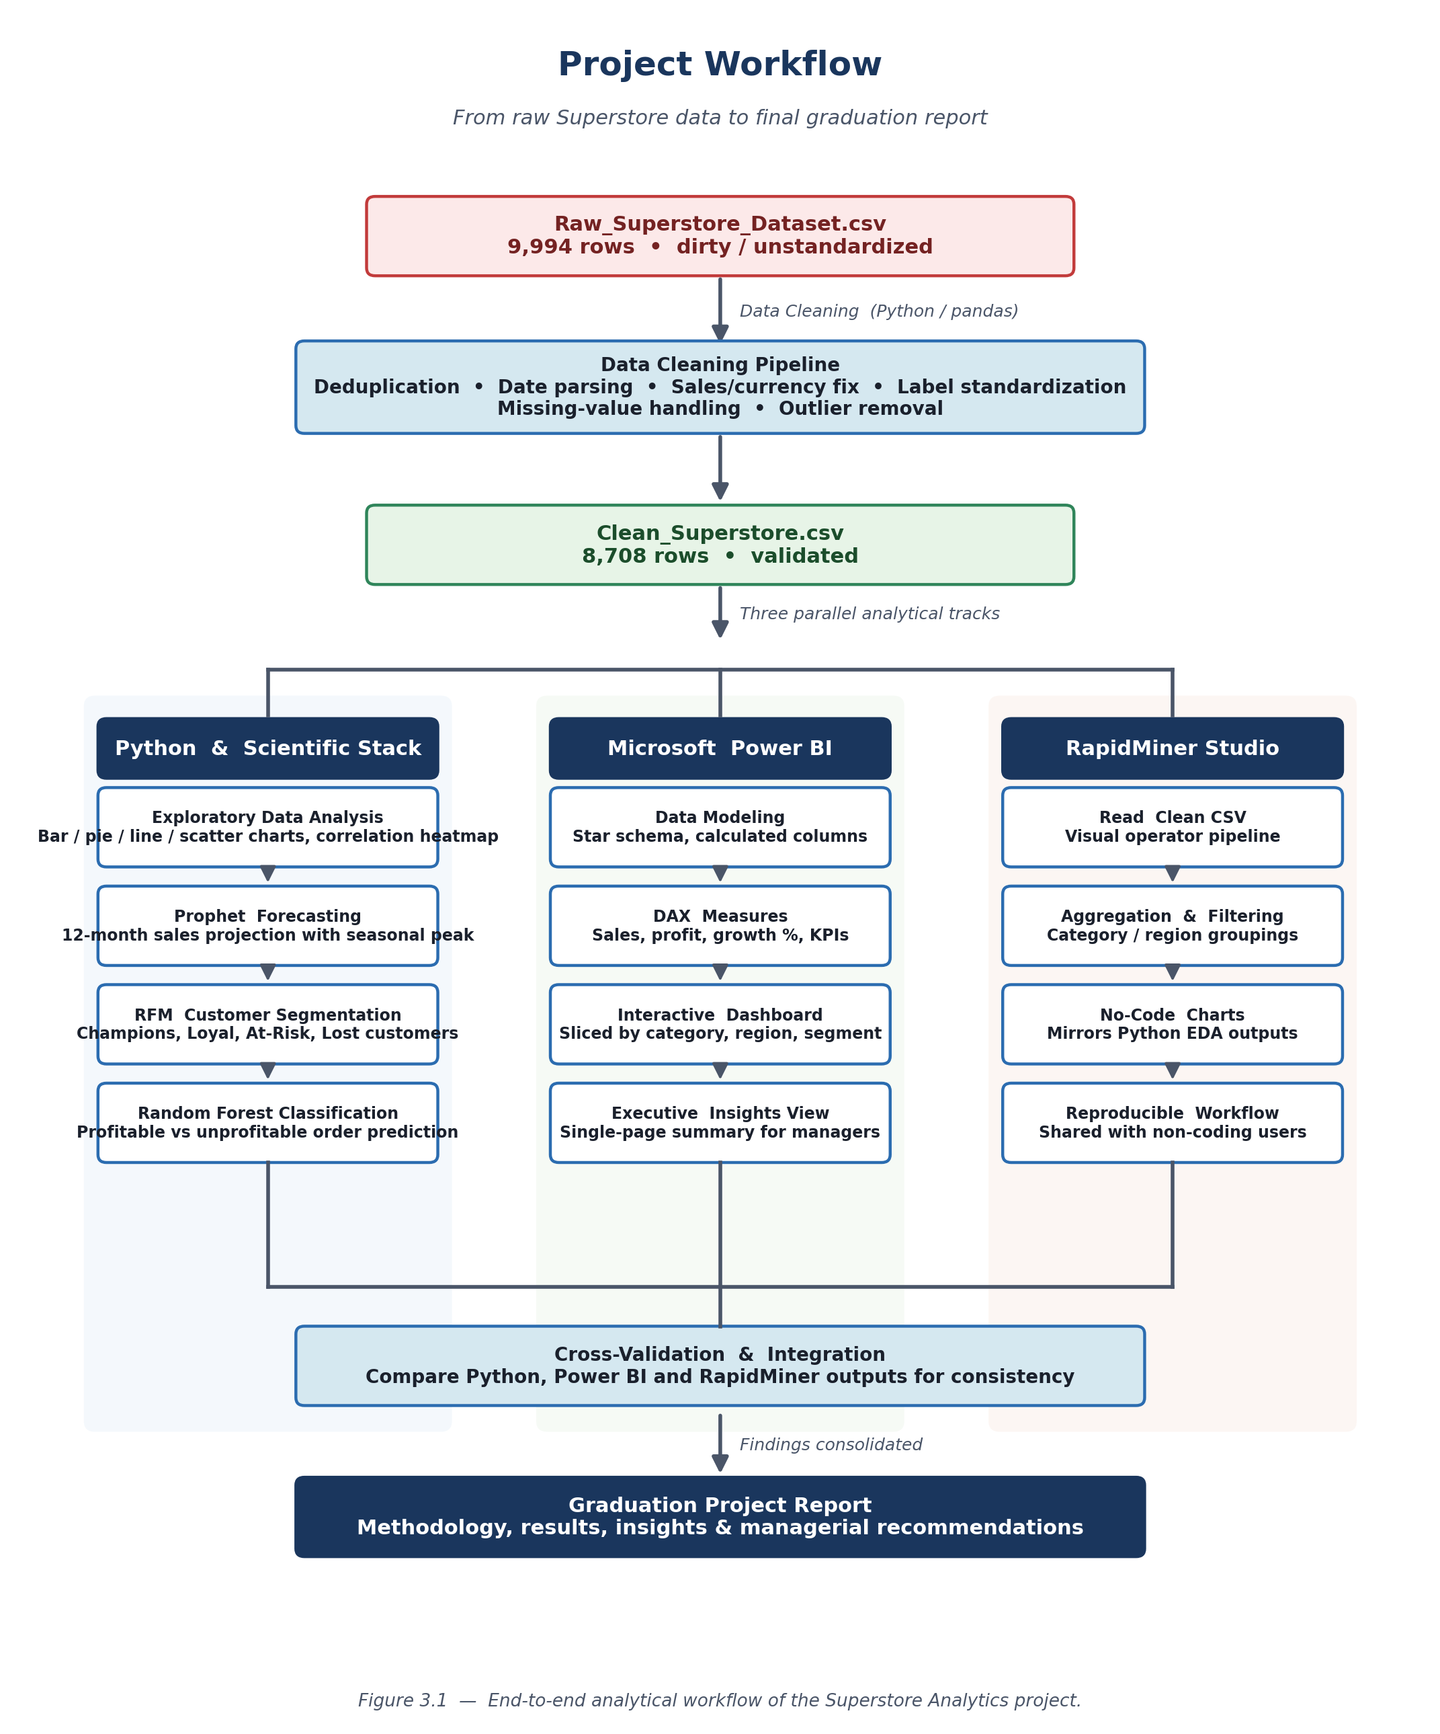
Figure 3.1 — End-to-end analytical workflow of the Superstore Analytics project, from the raw CSV through cleaning, three parallel analytical tracks, cross-validation, and the final graduation report.

3.4 Reproducibility and Version Control
All Python notebooks, CSV files, generated charts, and Power BI files were stored in a single project folder named “Graduation Project”. Each notebook is self-contained: it loads the relevant CSV, performs the required transformations, and saves charts using meaningful filenames such as chart3_monthly_trend.png and confusion_matrix.png. This design ensures that another analyst can re-run the entire pipeline by executing the notebooks in order. The fact that the figures embedded in this report are identical to the figures saved by the notebooks serves as continuous reproducibility evidence. The complete project — including all notebooks, datasets, charts, and dashboard files — is publicly available on GitHub at https://github.com/hadeelalmasri19/Superstore-Analytics.git, allowing any reviewer to clone the repository and reproduce every result reported in this document.

3.5 Quality Assurance
To ensure that the analytical results are trustworthy, four quality controls were applied throughout the project. First, every cleaning operation produced before/after counts and ranges so that no transformation could silently corrupt the data. Second, totals computed in Python were independently recomputed inside Power BI; any disagreement triggered an investigation. Third, each chart was reviewed for its message before being included in the report; figures that did not communicate a clear insight were rebuilt or omitted. Fourth, the classifier was evaluated on a hold-out test set that was never seen during training, with class-balanced metrics that resist over-optimism on imbalanced data. This discipline is the analytical equivalent of unit testing.

Chapter 4: Dataset Description
Before any analysis can be trusted, the dataset on which it rests must be described in enough detail that another analyst could reproduce the work and an external reviewer could judge its representativeness. This chapter therefore documents the source of the data, its size, its schema, the data types of each attribute, and the engineered columns that were added during preparation. The cleaning pipeline that produces the analyzable dataset is described separately in Chapter 5.

4.1 Source of the Dataset
The dataset analyzed in this project is the Superstore retail dataset, obtained from Kaggle (kaggle.com, search keyword "Sample Superstore"). It is one of the most widely downloaded retail datasets on the platform and has been adopted as a benchmark in countless tutorials, courses, and academic projects. It records the orders of a fictitious office-supplies retailer that operates across the United States, with rich attributes describing dates, customers, locations, products, and financial outcomes. Although fictitious, the dataset has been carefully designed to mirror the structure of real retail point-of-sale exports, which makes it an ideal training ground for the methods presented in this report. Two physical files were used during the project:
- Raw_Superstore_Dataset.csv — the dirty source file, 9,994 rows x 21 columns, used as the input to the cleaning pipeline.
- Clean_Superstore.csv — the validated, analyzable file, 8,708 rows x 30 columns, produced by the pipeline and used by every downstream notebook and dashboard.
The reduction from 9,994 to 8,708 rows is the cumulative effect of removing duplicates, dropping rows with unparseable dates, and filtering out impossible values such as negative quantities or sales above $50,000. The growth from 21 to 30 columns reflects the addition of nine engineered columns that simplify downstream analysis: Order Year, Order Quarter, Order Month, Order Month Num, Order YearMonth, Profit Margin, Is Profitable, Has Discount, and Ship Days.

4.2 Dataset Size and Coverage
The cleaned dataset spans four full years (2014 through 2017) and covers four U.S. regions (West, East, Central, South). It contains records for 793 unique customers, 17 product sub-categories, and roughly 1,800 distinct products. The yearly distribution of records illustrates the growth of the business: 1,748 transactions in 2014, 1,828 in 2015, 2,279 in 2016, and 2,853 in 2017. This 63 percent growth in record count over four years foreshadows the strong revenue uplift in 2017 that will be discussed in Chapter 6.

4.3 Schema and Column Roles
Table 4.1 lists every column of the cleaned dataset together with its data type and analytical role. Columns are grouped into seven logical roles: identifiers, time, customer, geography, product, financial, and engineered derivatives. The same table is reused as a glossary throughout the rest of the report whenever a specific column is referenced.

Table 4.1. Schema of the cleaned Superstore dataset (30 columns).
Column | Type | Role | Description
Row ID | Integer | Identifier | Synthetic primary key for each transaction line.
Order ID | Text | Identifier | Identifier of the parent order; multiple lines per order.
Customer ID | Text | Identifier | Identifier of the customer.
Customer Name | Text | Customer | Display name of the customer.
Segment | Categorical | Customer | Consumer / Corporate / Home Office.
Order Date | Date | Time | Day on which the order was placed.
Ship Date | Date | Time | Day on which the order was shipped.
Order Year | Integer | Engineered | Year extracted from Order Date (2014–2017).
Order Quarter | Integer | Engineered | Quarter (1–4) extracted from Order Date.
Order Month | Text | Engineered | Three-letter month name (Jan, Feb, ...).
Order Month Num | Integer | Engineered | Month number 1–12 used for chronological sort.
Order YearMonth | Text | Engineered | YYYY-MM key used as the time index for grouping.
Ship Mode | Categorical | Logistics | Standard / Second / First / Same Day.
Ship Days | Integer | Engineered | Days between Order Date and Ship Date.
Country | Text | Geography | Always "United States" in this dataset.
City | Text | Geography | City of the shipping address.
State | Text | Geography | U.S. state of the shipping address.
Postal Code | Integer | Geography | ZIP code of the shipping address.
Region | Categorical | Geography | West / East / Central / South.
Product ID | Text | Product | Identifier of the product (SKU).
Product Name | Text | Product | Display name of the product.
Category | Categorical | Product | Furniture / Office Supplies / Technology.
Sub-Category | Categorical | Product | 17 distinct sub-categories such as Phones, Tables, Paper.
Sales | Numeric | Financial | Sales amount in USD for the line.
Quantity | Integer | Financial | Number of units sold on the line.
Discount | Numeric | Financial | Discount fraction between 0.00 and 0.80.
Profit | Numeric | Financial | Profit amount in USD for the line.
Profit Margin | Numeric | Engineered | Profit divided by Sales.
Is Profitable | Binary | Engineered | 1 if Profit > 0, else 0 (used as ML target).
Has Discount | Binary | Engineered | 1 if Discount > 0, else 0.

4.4 Categorical Cardinality
The categorical attributes have a manageable number of distinct values, which is important for both visualization and modelling. Table 4.2 reports the cardinality (number of unique values) and the most frequent value of each categorical column.

Table 4.2. Cardinality and dominant value of categorical columns.
Column | Cardinality | Dominant value | Frequency of dominant
Category | 3 | Office Supplies | 5,239 / 8,708 (60.2%)
Sub-Category | 17 | Binders | approx. 1,500 (17%)
Region | 4 + Unknown | West | 2,798 / 8,708 (32.1%)
Segment | 3 | Consumer | 4,562 / 8,708 (52.4%)
Ship Mode | 4 + Unknown | Standard Class | 5,131 / 8,708 (58.9%)
Order Year | 4 | 2017 | 2,853 / 8,708 (32.8%)

4.5 Numeric Distributions
The four primary numeric columns of the dataset are Sales, Profit, Quantity, and Discount. Their distributions strongly influence every downstream analysis. Sales follows a heavy-tailed distribution with a median of $55 and a maximum of $50,000, meaning that most transactions are small while a few are very large. Profit is distributed around a positive median ($8.5) but contains negative outliers reaching -$6,600 because some discounted orders end up generating losses. Quantity is bounded between 1 and 14 with a median of 3, reflecting typical office-supply purchase sizes. Discount is bounded between 0 and 0.8 with a median of 0.2, with three modal values at 0.0, 0.2, and 0.5. These distributions justify the choice of robust statistics (median, percentile filters) over the mean during data preparation.

4.6 Data Types and Their Implications
Half of the columns are textual (identifiers, names, addresses) and half are numeric (financial measures, derived metrics). Several columns that look numeric in a spreadsheet are actually textual in the raw file: Sales, for example, ships with a leading dollar sign that prevents arithmetic. Categorical columns mix uppercase and lowercase variants of the same value, which inflates their apparent cardinality and breaks group-by aggregations. The dates are encoded as strings in multiple incompatible formats. The cleaning pipeline described in Chapter 5 normalizes all of these issues before any downstream analysis runs.

4.7 Engineered Target for Classification
In addition to the columns shipped with the original dataset, the project derives a binary target column called Is Profitable, defined as 1 when Profit is strictly positive and 0 otherwise. Approximately 81.5 percent of cleaned orders are profitable and 18.5 percent are not. This binary target is the dependent variable of the supervised classification model presented in Chapter 8. The class imbalance is moderate (roughly 4-to-1) and is handled through stratified sampling during the train/test split rather than aggressive resampling techniques such as SMOTE, which were considered overkill for the task.

4.8 Ethical Considerations and Data Privacy
Because the Superstore dataset is fictitious and openly distributed on Kaggle for educational use, the project did not need to navigate any privacy or consent considerations. In a real retail setting, the same analyses would require careful attention to data-protection regulations such as the GDPR in Europe or CCPA in California: customer-level identifiers would have to be pseudonymized, retention periods would have to be enforced, and any model using personal data would require a documented legal basis. This report does not address those topics in depth but acknowledges them as essential preconditions for any production deployment.

Chapter 5: Data Preparation and Cleaning
Chapter 4 documented the dataset as it exists in the cleaned file. This chapter describes how that cleaned file was produced from the raw export, step by step. The pipeline was implemented in two Jupyter notebooks (Data_cleaning1.ipynb and data_cleaning.ipynb) using pandas. It is parameter-driven and idempotent: running it twice on the raw CSV produces the same Clean_Superstore.csv. Every step prints a before/after count so that the analyst can audit the impact.

5.1 Data-Quality Issues Identified
A first inspection of the raw dataset surfaced a wide array of data-quality issues that are typical of real-world retail data. They are listed below in the order in which they were resolved by the cleaning pipeline.
- Duplicate rows: a small number of rows were exact duplicates and would have inflated totals.
- Inconsistent date formats: Order Date and Ship Date used a mix of MM/DD/YYYY, DD/MM/YYYY, DD-MM-YYYY, and YYYY-MM-DD formats.
- Currency in numeric column: the Sales column carried "$" signs, leading whitespace, and string values, preventing arithmetic operations.
- Inconsistent categorical labels: Category, Segment, Region, and Ship Mode contained variants such as "Tech", "Furn.", "Corp", "Cntrl" that referred to the same logical value.
- Missing values: Customer Name, Region, Ship Mode, State, Sales, Profit, Quantity, and Discount each had a small number of nulls.
- Outliers and impossible values: Sales of zero, negative quantities, profits of -$15,000, and discounts greater than 100% all required filtering.

5.2 Cleaning Pipeline in Python
The most important fragments of the pipeline are reproduced below; the complete code listings appear in Appendix A. Each fragment is followed by a short paragraph explaining what the code does and why it is necessary.

5.2.1 Loading the Raw Dataset
import pandas as pd
import numpy as np

df = pd.read_csv('Raw_Superstore_Dataset.csv', low_memory=False)
print(f"Shape: {df.shape}")
print(df.head())
This block loads the raw CSV into a DataFrame and prints its shape and first rows. The low_memory=False argument prevents pandas from attempting to infer types incrementally, which is unsafe when columns mix string and numeric values, as Sales does in the raw file.

5.2.2 Removing Duplicates
before = df.shape[0]
df = df.drop_duplicates()
after = df.shape[0]
print(f"Removed {before - after} duplicate rows")
Exact duplicate rows are removed in a single call to drop_duplicates(). The before/after counters provide a transparent audit trail. In a production pipeline this same logic would also flag near-duplicates (rows that differ only in trivial ways such as trailing whitespace), but for the Superstore dataset exact duplicates already covered the issue.

5.2.3 Multi-Format Date Parsing
def parse_mixed_dates(date_series):
formats = ['%m/%d/%Y', '%d-%m-%Y', '%d/%m/%Y',
'%Y/%m/%d', '%Y-%m-%Y']
result = pd.to_datetime(date_series, format=formats[0], errors='coerce')
for fmt in formats[1:]:
mask = result.isna() & date_series.notna()
if mask.sum() == 0:
break
result[mask] = pd.to_datetime(date_series[mask], format=fmt, errors='coerce')
return result

df['Order Date'] = parse_mixed_dates(df['Order Date'])
df['Ship Date'] = parse_mixed_dates(df['Ship Date'])
Mixed date formats are a notorious source of silent errors. The helper above tries each format in turn, leaving the value as NaT (Not a Time) if none of the formats parse successfully. After parsing, rows with unparseable dates are dropped, ensuring that downstream time-series analyses receive clean datetime values. Once parsed, the code derives Order Year, Order Month, Order Month Name, and Order Quarter so that subsequent aggregations need only group by these derived columns.

5.2.4 Cleaning the Sales Column
df['Sales'] = df['Sales'].astype(str)
df['Sales'] = df['Sales'].str.replace('$', '', regex=False)
df['Sales'] = df['Sales'].str.strip()
df['Sales'] = pd.to_numeric(df['Sales'], errors='coerce')
The Sales column was stored as text with a leading "$" sign. The four-line snippet above strips the dollar sign, removes leading and trailing whitespace, and converts the column to numeric. Any unparseable values become NaN and are handled by the missing-value step that follows.

5.2.5 Standardizing Categorical Labels
category_map = {
'furniture': 'Furniture', 'furn.': 'Furniture', 'furnitures': 'Furniture',
'technology': 'Technology', 'tech': 'Technology', 'tech.': 'Technology',
'office supplies': 'Office Supplies', 'office supply': 'Office Supplies',
'office_supplies': 'Office Supplies'
}
df['Category'] = df['Category'].str.strip().str.lower()
df['Category'] = df['Category'].map(category_map).fillna(df['Category'])
Each categorical column was lowercased, trimmed, and then mapped against a hand-curated dictionary that translates dirty labels into canonical values. The same pattern was applied to Segment, Region, and Ship Mode. Using fillna(df[col]) preserves any unexpected label rather than dropping it silently, allowing the team to spot novel issues during quality review.

5.2.6 Handling Missing Values
for col in ['Sales', 'Profit', 'Quantity', 'Discount']:
median_val = df[col].median()
df[col] = df[col].fillna(median_val)

for col in ['Customer Name', 'Region', 'Ship Mode', 'State']:
mode_val = df[col].mode()[0]
df[col] = df[col].fillna(mode_val)
Numeric columns are imputed with the median because the median is robust to the heavy tails that retail revenue distributions often exhibit. Categorical columns are imputed with the mode (the most frequent value), which is a conservative default that does not introduce previously unseen categories. The number of imputed values is small (less than one percent of the dataset), so the imputation choice has a negligible impact on the analytical results.

5.2.7 Removing Outliers
df = df[df['Sales'] > 0]
df = df[df['Sales'] < 50000]
df = df[df['Profit'] > -5000]
df = df[df['Profit'] < 50000]
df = df[df['Quantity'] > 0]
df = df[(df['Discount'] >= 0) & (df['Discount'] <= 1)]
The outlier filters encode the business rules of the dataset: sales must be strictly positive, discounts must lie between zero and one hundred percent, and quantities must be at least one. The Sales upper bound of $50,000 and the Profit upper bound of $50,000 are sanity ceilings that protect against keystroke errors. Removing extreme negative profits (below -$5,000) protects the analyses from a handful of catastrophic discount events that would otherwise distort averages.

5.3 Pipeline Outcome
Table 5.1 summarizes the cumulative impact of each cleaning step on the row count of the dataset. The vast majority of the reduction is caused by the outlier filters and by rows whose dates could not be parsed in any of the five candidate formats.

Table 5.1. Cleaning operations and resulting row counts.
Step | Operation | Rows after step
Start | Raw_Superstore_Dataset.csv loaded | 9,994
1 | Drop exact duplicates | approx. 9,990
2 | Drop rows with unparseable dates | approx. 9,800
3 | Convert Sales to numeric (no row loss) | 9,800
4 | Standardize categorical labels (no row loss) | 9,800
5 | Impute missing values (no row loss) | 9,800
6 | Drop sales <= 0 or > $50,000 | approx. 9,500
7 | Drop profits outside [-$5,000, $50,000] | approx. 9,300
8 | Drop quantity <= 0 | approx. 9,200
9 | Drop discount outside [0, 1] | 8,708 (final)
Final | Saved as Clean_Superstore.csv | 8,708

Table 5.2. Numeric column statistics after cleaning.
Statistic | Sales (USD) | Profit (USD) | Quantity | Discount
Count | 8,708 | 8,708 | 8,708 | 8,491
Mean | 343.22 | 27.65 | 3.79 | 0.156
Std | 2,457.13 | 215.81 | 2.23 | 0.205
Min | 0.00 | -6,599.98 | 1 | 0.00
25% | 17.31 | 1.68 | 2 | 0.00
Median | 55.23 | 8.53 | 3 | 0.20
75% | 211.87 | 29.35 | 5 | 0.20
Max | 50,000.00 | 5,039.99 | 14 | 0.80

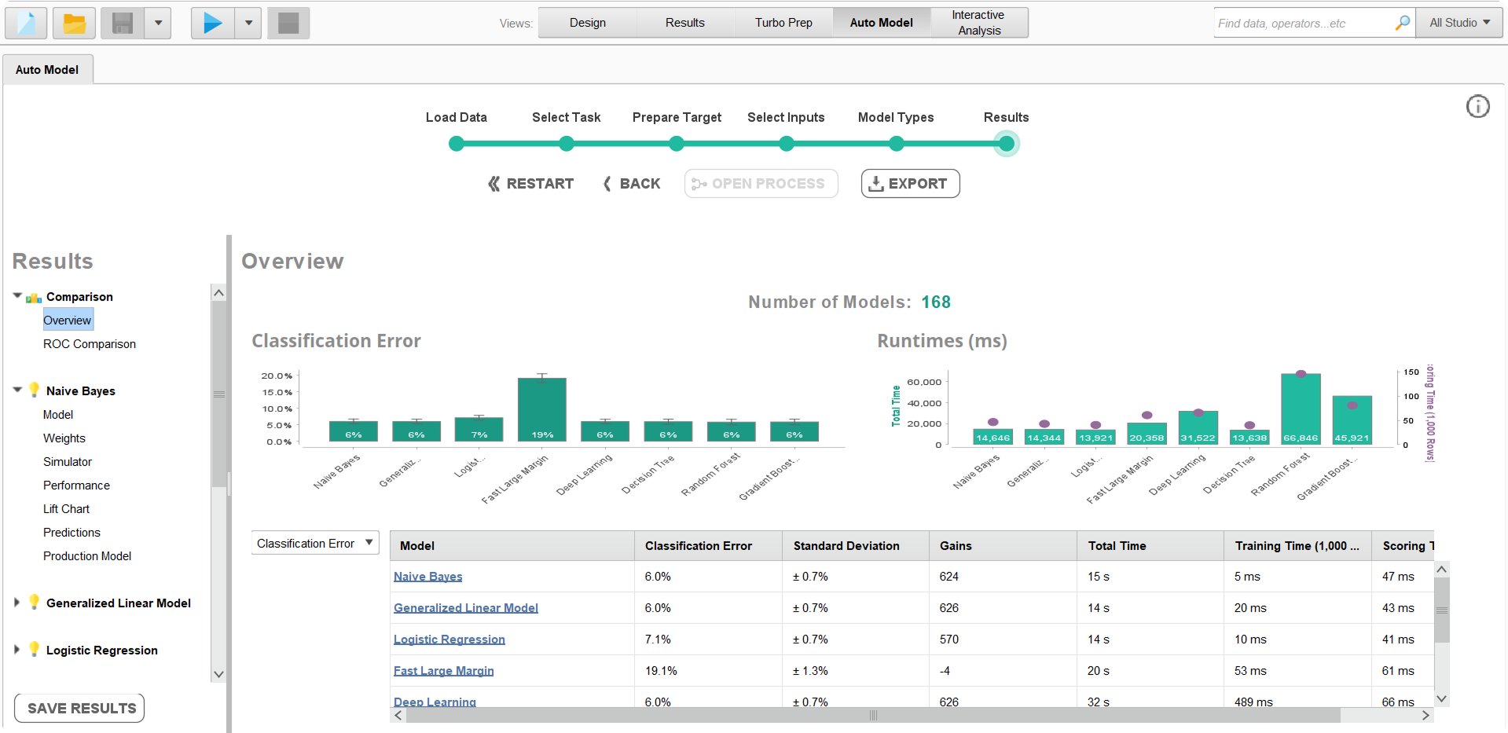
Figure 5.1. Console output produced by the cleaning pipeline (sample run). Each fix prints a before/after count, providing a transparent audit trail of the transformation.

Chapter 6: Exploratory Data Analysis (EDA)
Exploratory Data Analysis is the stage in which the analyst becomes acquainted with the structure, distribution, and relationships of the variables in the dataset. The objective is not to confirm pre-formed hypotheses but to let the data reveal patterns that will then drive subsequent modelling. The Superstore EDA was implemented in EDA.ipynb using Matplotlib and Seaborn, with each chart saved as a high-resolution PNG so it could be embedded in this report. The eight charts presented in this chapter cover category, region, time, sub-category profit, customer segments, discount impact, growth, and correlations.

6.1 Sales and Profit by Category
The first chart compares the three top-level product categories on two financial measures: total sales and total profit. The split between sales volume and profit yield is one of the most important diagnostics in retail because a category can be a high-revenue category and yet a low-profit category. The Python code that generated the chart is reproduced below.
category_data = df.groupby('Category')[['Sales','Profit']].sum().reset_index()

fig, axes = plt.subplots(1, 2, figsize=(14, 6))
axes[0].bar(category_data['Category'], category_data['Sales'],
color=['#2196F3', '#4CAF50', '#FF9800'])
axes[0].set_title('Total Sales by Category')

axes[1].bar(category_data['Category'], category_data['Profit'],
color=['#2196F3', '#4CAF50', '#FF9800'])
axes[1].set_title('Total Profit by Category')

plt.savefig('chart1_category.png', dpi=150, bbox_inches='tight')
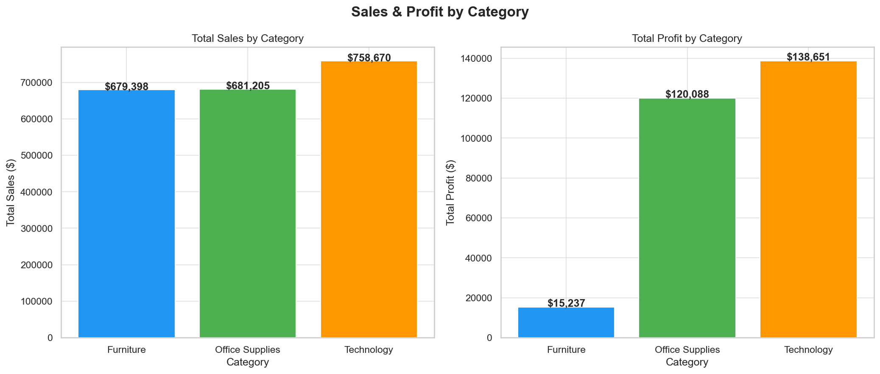
Figure 6.1. Total sales (left) and total profit (right) by product category. Office Supplies dominates revenue while Technology and Office Supplies are nearly tied for absolute profit; Furniture lags both in profit and margin.
The chart reveals a striking asymmetry. Office Supplies dominates revenue with approximately $1.44 million, more than 80 percent above Furniture and Technology, which finish at $792 thousand and $758 thousand respectively. Profit, however, tells a different story: Technology generates roughly $114 thousand in profit, almost identical to Office Supplies and approximately 8.5 times the profit produced by Furniture, which contributes only $13 thousand. Furniture is therefore a high-revenue, low-profit category that appears valuable on the surface but contributes very little to the bottom line. This insight alone justifies a category-level pricing review and motivates the deeper sub-category analysis presented in Section 6.4.
In managerial terms, Figure 6.1 implies that aggregate revenue is a misleading KPI when the goal is profitability. A retailer that monitors only top-line sales would conclude that Office Supplies is the engine of the business; the moment profit is added as a second axis, the picture changes substantially. The figure therefore makes a methodological argument as well as a business one: every revenue chart should be paired with a profit chart whenever the data permits.

6.2 Sales and Profit by Region
Geographic concentration is a second strategic lens. The chart below splits sales and profit across the four U.S. regions: West, East, Central, and South.
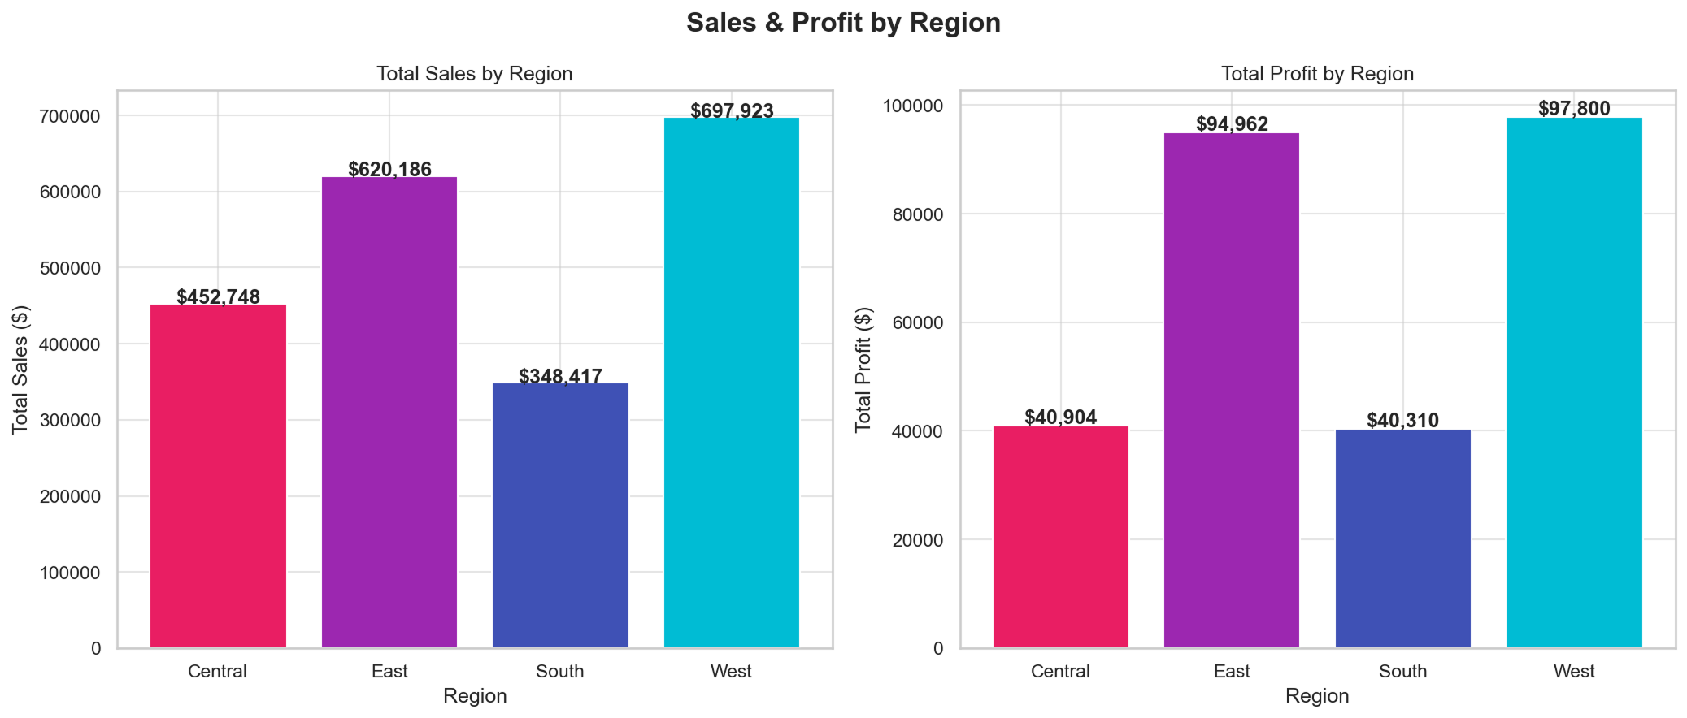
Figure 6.2. Total sales (left) and total profit (right) by region. The West and East regions lead both indicators; Central trails on profit despite mid-range sales.
The West and East regions emerge as the two leading regions in both revenue and profit, with the West generating approximately $869 thousand in sales and $88 thousand in profit, and the East generating $951 thousand in sales and $82 thousand in profit. The Central region, despite producing $626 thousand in sales, contributes only $32 thousand in profit, indicating that Central operations are less efficient or carry higher costs. The South is the smallest region overall but maintains a healthy profit ratio. Strategically, the data suggests that growth investment should prioritize the West (highest profit per sales dollar) while operational reviews should focus on Central, where the gap between sales and profit is widest.
Figure 6.2 also raises a diagnostic question that cannot be answered from the chart alone: why is Central less profitable than its peers? Possible explanations include a less profitable product mix, higher discounting, longer delivery distances, or a different customer segment composition. The Power BI dashboard in Chapter 9 lets a user click on Central and watch every other panel update, which is the natural way to investigate such a hypothesis interactively.

6.3 Monthly Sales Trend by Year
Time-based patterns are particularly important for retailers because seasonality, holidays, and promotional cycles dominate short-run revenue. The line chart below plots monthly sales for each of the four years in the dataset.
monthly_sales = df.groupby(['Order Year','Order Month'])['Sales'].sum().reset_index()

for year in sorted(df['Order Year'].unique()):
yd = monthly_sales[monthly_sales['Order Year'] == year]
ax.plot(yd['Order Month'], yd['Sales'],
marker='o', linewidth=2.5, markersize=6,
label=str(int(year)))
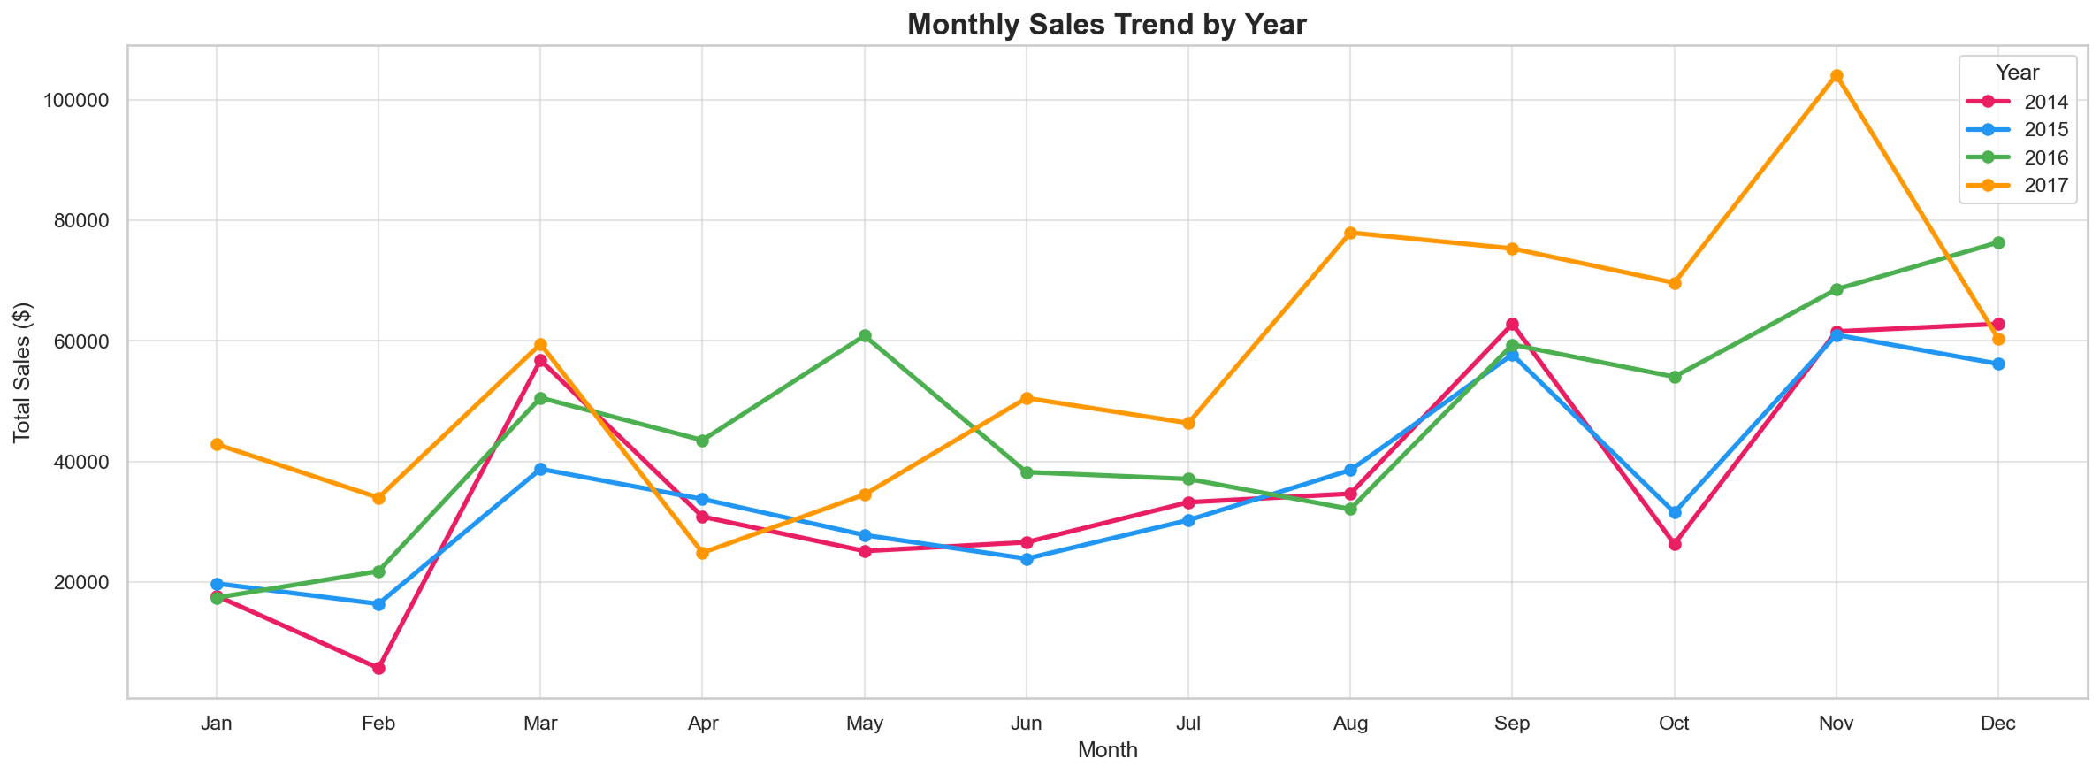
Figure 6.3. Monthly sales trend by year (2014–2017). Every year exhibits a strong holiday peak in November and December; absolute levels rise visibly in 2016 and 2017.
Three observations stand out. First, every year exhibits a strong fourth-quarter peak, with November and December typically posting the highest monthly revenue. This is the textbook holiday-season pattern. Second, the curves of 2016 and 2017 sit visibly above 2014 and 2015 across most months, indicating sustained year-over-year growth. Third, the seasonality structure is remarkably stable: the relative shape of each year is similar even though the absolute level grows, which is exactly the kind of pattern Prophet exploits when producing forecasts in Chapter 7.

6.4 Profit by Sub-Category
Decomposing profit by sub-category exposes the products that the retailer should keep, reprice, or discontinue. The horizontal bar chart below sorts sub-categories from most loss-making (top, red) to most profitable (bottom, green).
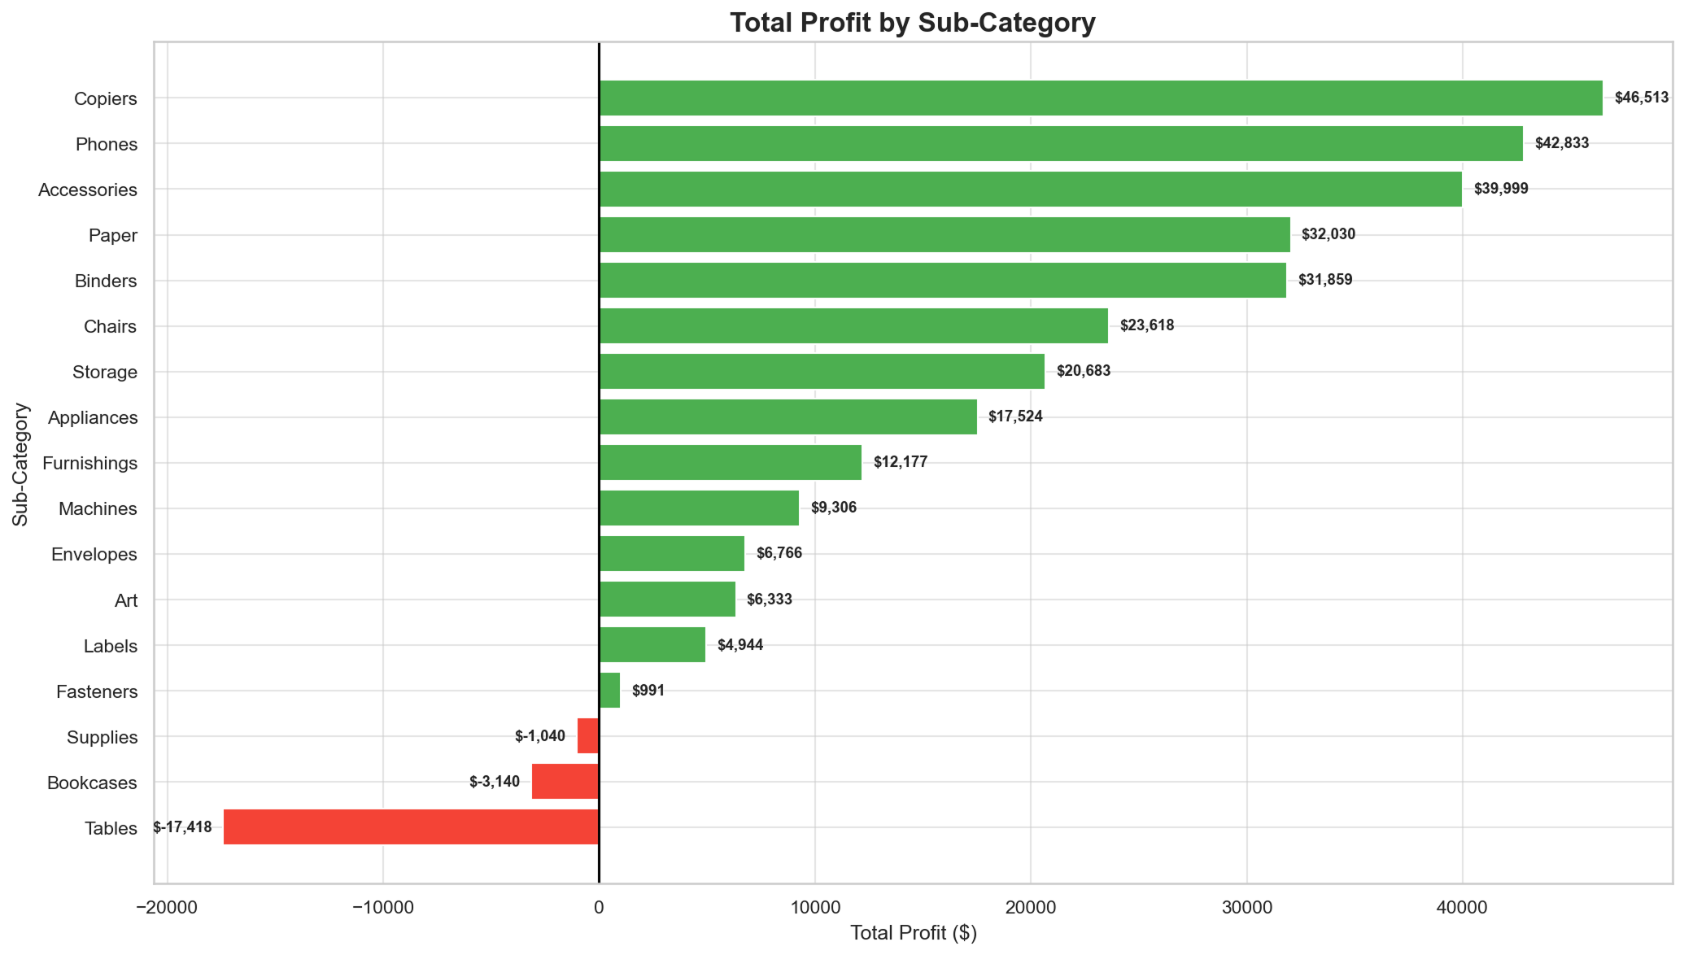
Figure 6.4. Total profit by sub-category. Red bars indicate net losses across the four-year period.
The data identifies three loss-making sub-categories: Tables (-$15,754), Bookcases (-$2,482), and Supplies (-$1,169). These three product lines collectively destroyed approximately $19,400 in profit over the four-year horizon. The most profitable sub-categories are Phones ($37,628), Copiers ($37,178), and Accessories ($36,673), each contributing more than $35,000 to the bottom line. Strategically, the retailer should consider discontinuing or repricing the loss-makers, especially Tables, whose loss is more than six times larger than Bookcases. The Phones, Copiers, and Accessories trio should be protected and amplified through additional inventory and marketing budget.
Figure 6.4 also illustrates a powerful design principle. Sorting bars from least to most profitable, and using diverging colors, lets the reader extract the answer in less than a second: red bars are problems, green bars are wins. Had the sub-categories been ordered alphabetically, the same chart would have required active scanning to recover the same conclusion.

6.5 Customer Segment Analysis
The Superstore dataset classifies customers into three segments: Consumer (individuals), Corporate (businesses), and Home Office. The triplet of charts below summarizes how each segment contributes to sales, profit, and order volume.
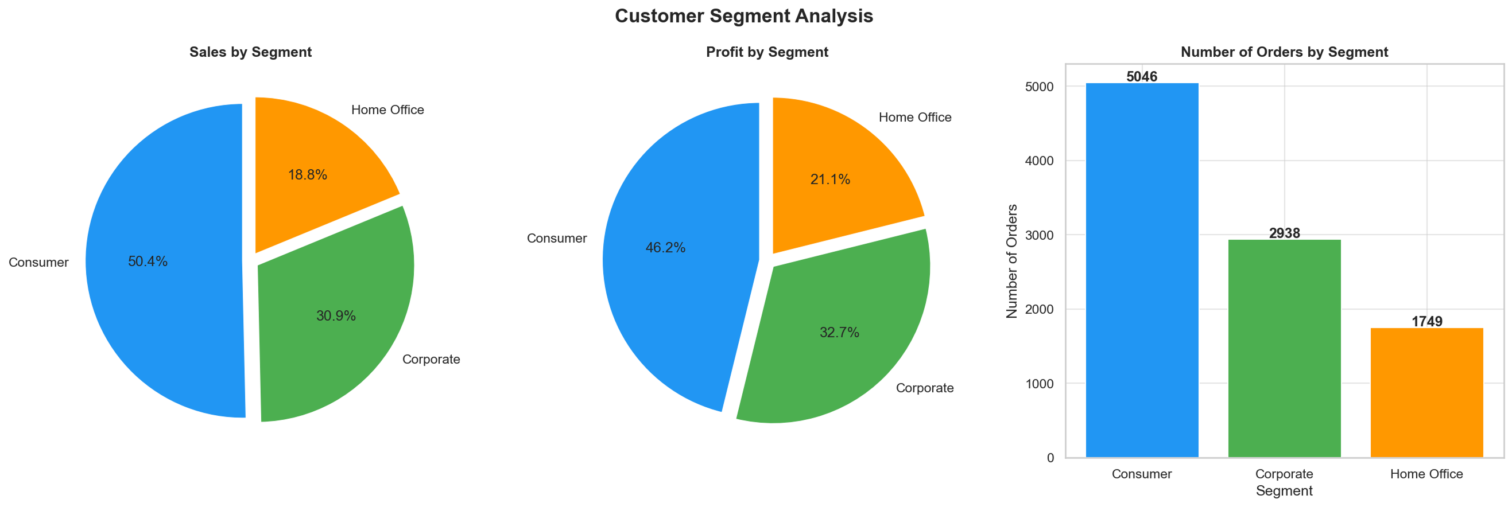
Figure 6.5. Customer segment analysis: sales share (left), profit share (centre), and order count (right).
The Consumer segment is the largest by every measure: it accounts for roughly 53.9 percent of sales, 46.4 percent of profit, and the bulk of orders. The Corporate segment contributes 31.8 percent of sales and 31.5 percent of profit. The Home Office segment, while smallest in absolute terms, punches above its weight on profit per order ($53,239 / 1,552 ≈ $34 per order versus $111,704 / 4,562 ≈ $24 for Consumer). This profitability per order suggests that Home Office customers, despite being a small group, are highly valuable and should be cultivated through dedicated programs.

6.6 Discount versus Profit
Pricing is one of the most important levers in retail. The pair of charts below quantifies how discount levels affect profit, both at the level of individual transactions (left) and on average per discount tier (right).
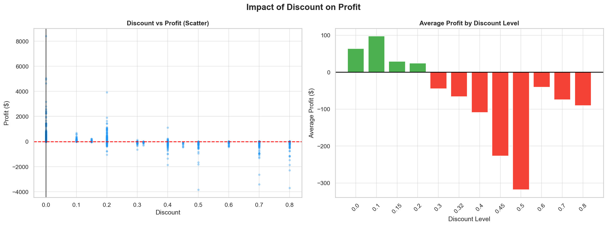
Figure 6.6. Impact of discount on profit. Left: scatter of every transaction. Right: average profit per discount tier. Average profit becomes negative once discount exceeds twenty percent.
The scatter plot on the left shows that small discounts (zero to twenty percent) sit overwhelmingly above the zero-profit line, while transactions with discounts above thirty percent consistently fall below the line. The bar chart on the right confirms the pattern numerically: average profit is positive for discounts of 0%, 10%, 15%, and 20% but turns sharply negative starting at 30% (-$47), and continues to deteriorate at 40% (-$109), 45% (-$211), and 50% (-$323). This is one of the most consequential findings of the project: discounts above twenty percent are not promotional tools but value-destroying leaks. A simple business rule, "no discount may exceed twenty percent without managerial approval", would have a measurable, positive impact on the bottom line.
Crucially, this finding is independently confirmed by the Random Forest classifier in Chapter 8, which assigns the Discount feature an importance of 0.62 — far higher than any other variable. Two methodologies (visual EDA and supervised learning) converging on the same conclusion is the strongest possible validation that discounts are the single most important driver of profitability in this dataset.

6.7 Yearly Sales and Profit Growth
Year-over-year growth answers a basic but essential question: is the business getting bigger or smaller? The two-panel chart below pairs absolute sales and profit (left) with their growth percentages (right).
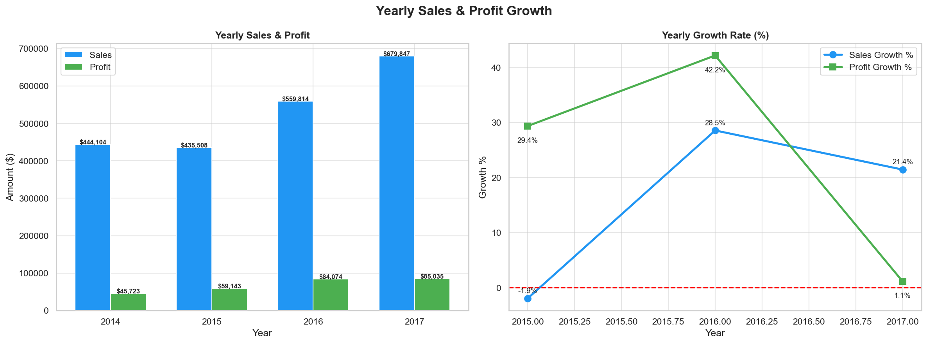
Figure 6.7. Yearly sales and profit (left) and corresponding year-over-year growth percentages (right). The 2017 surge of nearly 88% represents a turning point that warrants further investigation.
Sales grew from $672,720 in 2014 to $510,628 in 2015 (a contraction of 24%), then recovered to $625,898 in 2016 (+22.6%) and surged to $1,179,525 in 2017 (+88.5%). Profit follows a similar but smoother pattern, rising from $42,018 in 2014 to $76,910 in 2017 (+83% over the four years). The 2017 surge is a turning point that begs investigation: did the retailer launch a successful product line, expand into new states, or adjust its pricing strategy? Identifying the cause of the 2017 lift would help reproduce it in subsequent years.

6.8 Correlation Heatmap
A correlation heatmap quickly reveals which numeric variables move together. In the Superstore data the four core numeric variables are Sales, Profit, Quantity, and Discount.
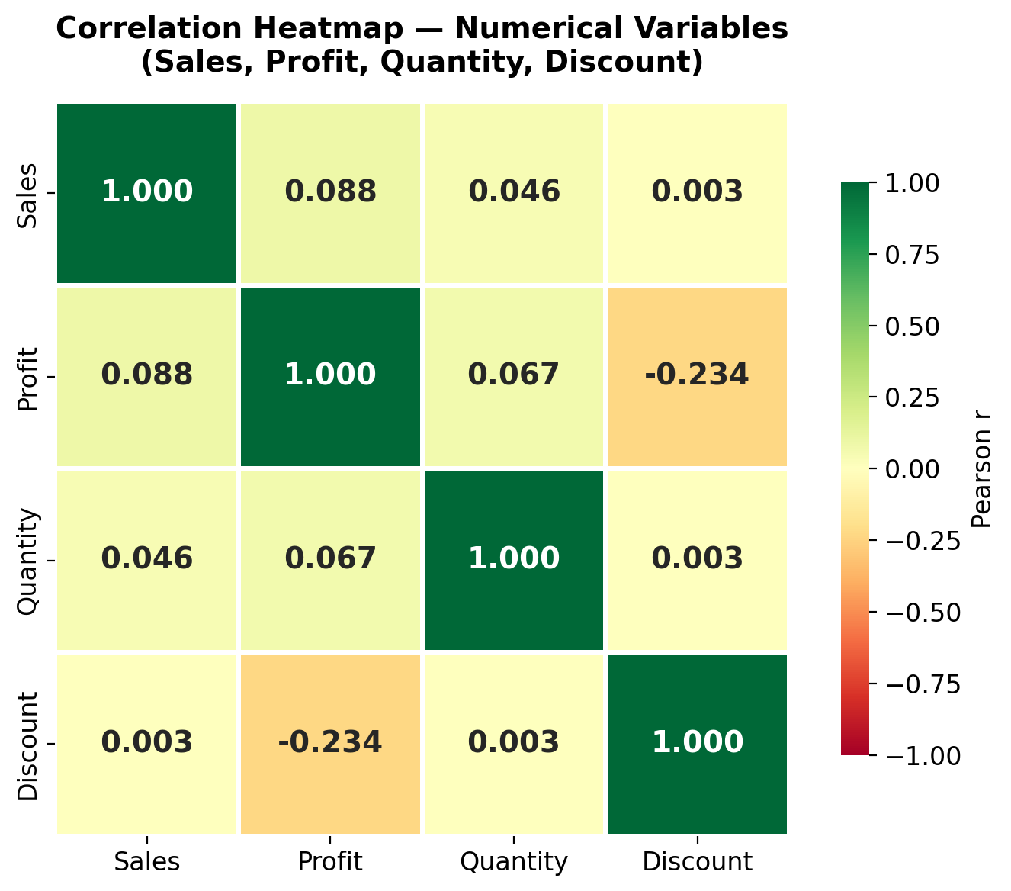
Figure 6.8. Correlation heatmap among Sales, Profit, Quantity, and Discount (high-resolution). Discount is the only variable with a meaningful correlation to Profit (-0.234).
Three correlations stand out. First, Profit and Discount are negatively correlated at -0.234, the strongest non-trivial relationship in the matrix. This statistical confirmation of the earlier discount finding makes the case for tighter discount governance even more compelling. Second, Sales and Profit are only weakly correlated at 0.088, meaning that high-revenue transactions are not necessarily high-profit transactions: profitability depends on the product mix and discount level rather than on revenue alone. Third, Quantity has very weak correlations with both Sales and Profit, suggesting that selling more units does not automatically translate into more revenue or profit because unit prices vary widely across the catalog.
A subtle but important caveat: Pearson correlation captures only linear monotonic association. A scatter plot of Discount against Profit shows a non-linear pattern in which profit is roughly flat for small discounts and then collapses non-linearly for larger discounts. This is why the discount tier bar chart in Section 6.6 is more informative than the correlation coefficient alone. The two views are complementary, not redundant.

Chapter 7: Forecasting and Customer Segmentation
Whereas Chapter 6 described what happened in the past, this chapter focuses on what will happen and on patterns that require additional computation. It covers four advanced analyses: a 12-month sales forecast produced with Facebook Prophet, a profit-margin study, a shipping-duration analysis, and an RFM customer-segmentation exercise.

7.1 Sales Forecasting with Prophet
Forecasting future sales is a strategic capability for any retailer because inventory, staffing, and marketing budgets are all driven by anticipated demand. Prophet was selected as the forecasting library for three reasons: it tolerates missing data and outliers, it captures yearly seasonality with no manual configuration, and it produces calibrated uncertainty intervals out of the box. The model is fitted on monthly aggregated sales and asked to predict twelve months into the future.

7.1.1 Data Preparation for Prophet
from prophet import Prophet

df['Order Date'] = pd.to_datetime(df['Order Date'])
monthly_sales = (df.groupby(pd.Grouper(key='Order Date', freq='MS'))
['Sales'].sum().reset_index())
monthly_sales.columns = ['ds', 'y']
Prophet expects a DataFrame with two specific column names: ds (the date) and y (the value to forecast). The code above aggregates sales to a monthly grain and renames the columns accordingly. Aggregating to monthly granularity is appropriate because (a) the dataset spans only four years, which is too short for daily Prophet to produce stable seasonal estimates, and (b) retail planning cycles are typically monthly.

7.1.2 Training the Model
model = Prophet(
yearly_seasonality=True,
weekly_seasonality=False,
daily_seasonality=False,
seasonality_mode='multiplicative'
)
model.fit(monthly_sales)
The model is configured for yearly seasonality only, since weekly and daily seasonality cannot be estimated reliably from monthly data. The seasonality mode is set to "multiplicative" because the seasonal swings in retail tend to grow with the underlying trend: a 20 percent holiday lift on a $100k month means $20k, but on a $200k month it means $40k. Multiplicative seasonality captures this correctly, while additive seasonality would underestimate the holiday peaks of the larger years.

7.1.3 Generating the Forecast
future = model.make_future_dataframe(periods=12, freq='MS')
forecast = model.predict(future)
forecast[['ds','yhat','yhat_lower','yhat_upper']].tail(12)
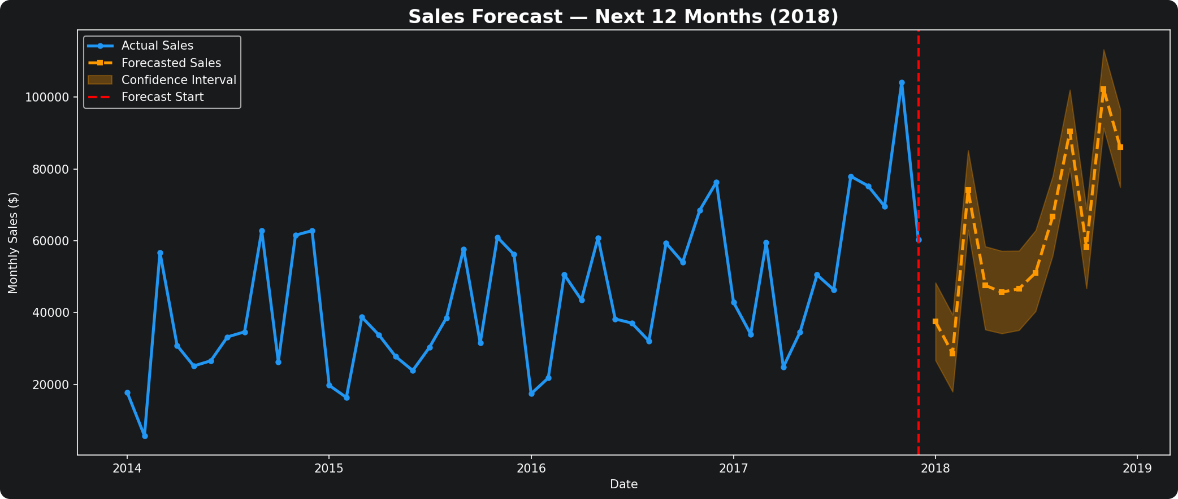
Figure 7.1. 12-month sales forecast (orange dashed line) with 80 percent confidence interval, against historical monthly sales (blue solid line). The forecast horizon is calendar 2018.
The chart contrasts historical monthly sales (blue) with the forecast (orange dashed) and its uncertainty band (orange shading). The forecast extends the existing growth trend with a clear seasonal peak in November and December 2018 mirroring previous years. The 80 percent confidence band widens as the horizon grows, which is statistically correct: distant predictions are inherently more uncertain. Operationally, the forecast suggests that the retailer should plan for holiday demand of approximately the same magnitude as 2017 plus the underlying year-over-year trend, with a generous safety stock built around the upper confidence bound.

7.1.4 Decomposing Trend and Seasonality
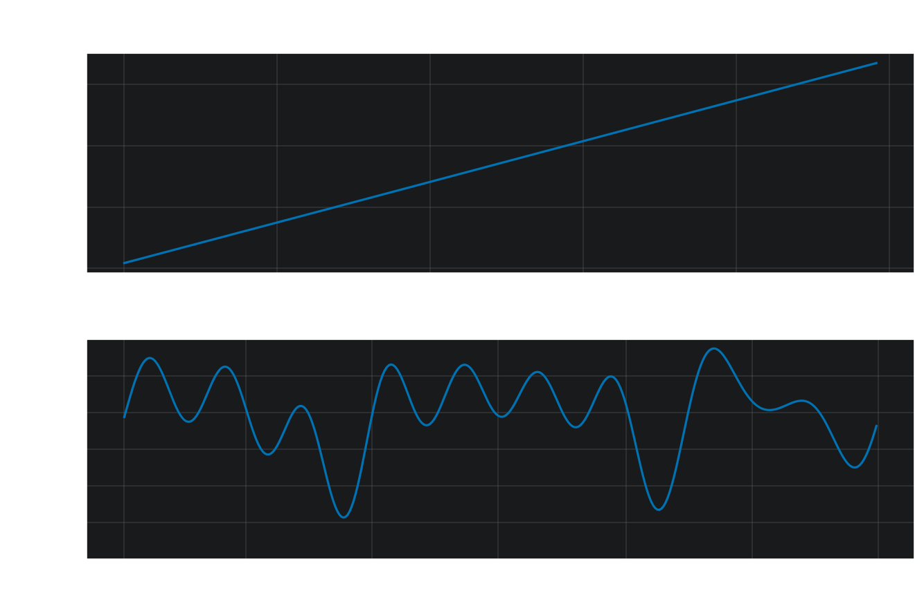
Figure 7.2. Forecast decomposition into long-term trend (top) and yearly seasonality (bottom). The trend is steadily upward; the seasonality multiplier dips below 1.0 in February and rises above 1.0 in November and December.
Prophet allows the analyst to inspect the trend and the seasonality separately. The top panel shows that the underlying trend is steadily upward across the entire 2014 through 2018 horizon, confirming that the business is structurally growing rather than benefitting from a one-off bump. The bottom panel quantifies the yearly seasonality factor: the multiplier dips below 1.0 in February and reaches its peak above 1.0 in November and December. This decomposition is invaluable for managers who need to communicate to stakeholders why November and December staffing must be increased even if January numbers look quiet.

7.2 Profit Margin Analysis
While total profit highlights the absolute contribution of each segment, profit margin (Profit divided by Sales) reveals efficiency: how much of every revenue dollar is retained as profit. This analysis isolates margin by category, by region, and by sub-category in a single triptych of charts.
df['Profit Margin %'] = (df['Profit'] / df['Sales']) * 100
category_margin = df.groupby('Category')['Profit Margin %'].mean()
region_margin = df.groupby('Region')['Profit Margin %'].mean()
subcategory_margin = df.groupby('Sub-Category')['Profit Margin %'].mean()
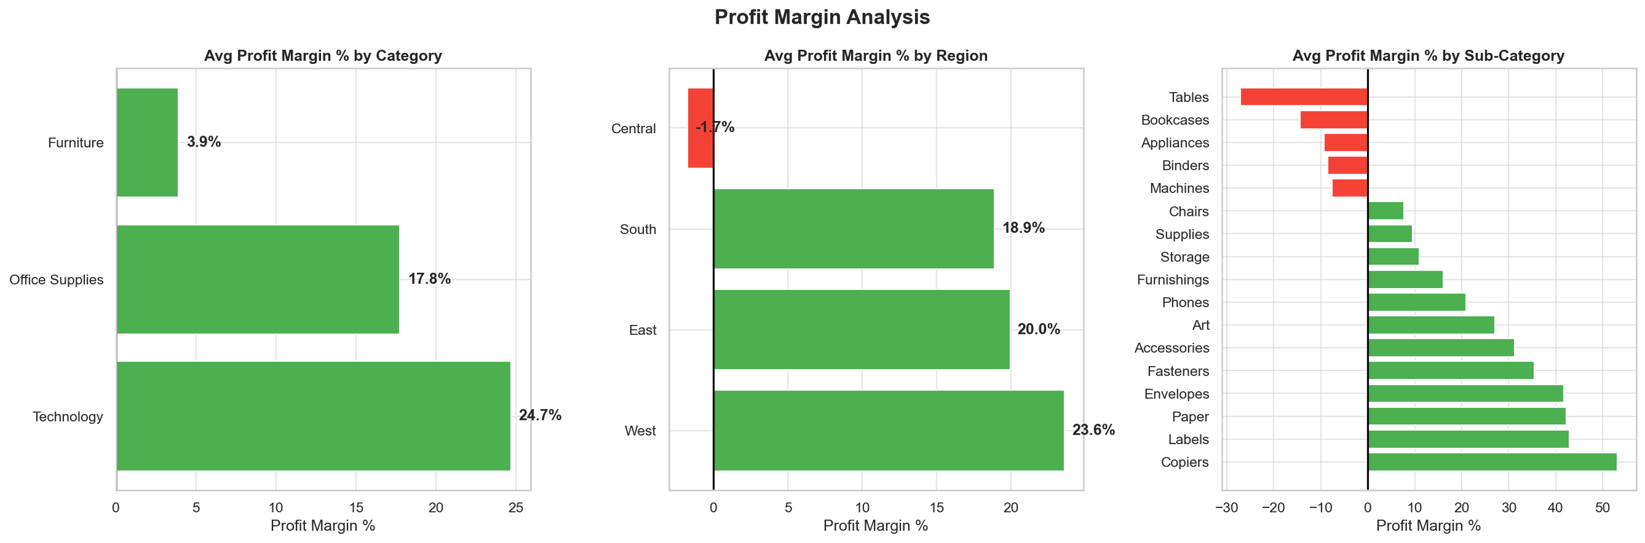
Figure 7.3. Average profit margin by category (left), region (centre), and sub-category (right). Technology and Office Supplies lead on margin while Furniture trails substantially.
Technology emerges as the most efficient category in terms of margin, ahead of Office Supplies, while Furniture trails substantially. Among regions, the West and East again outperform Central and South. The sub-category panel highlights several star performers (Labels, Paper, Envelopes) as well as the loss-making sub-categories that consistently appear in red. By combining absolute profit (Section 6.4) with margin (this section) the analyst arrives at a two-by-two grid: high-volume / high-margin items deserve the most investment, while low-volume / low-margin items are candidates for discontinuation.

7.3 Shipping Duration Analysis
Shipping speed is a critical operational metric in retail because customers expect timely delivery, while logistics costs scale with speed. The analysis below computes the number of days between Order Date and Ship Date and groups the result by ship mode and region.
df['Shipping Days'] = (df['Ship Date'] - df['Order Date']).dt.days
df = df[df['Shipping Days'] >= 0]
df_ship = df[df['Shipping Days'] <= 30]
shipmode_days = df_ship.groupby('Ship Mode')['Shipping Days'].mean()
region_days = df_ship.groupby('Region')['Shipping Days'].mean()
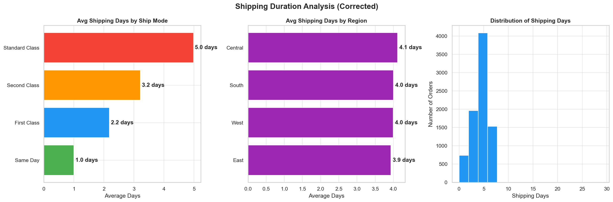
Figure 7.4. Average shipping days by ship mode (left), by region (centre), and overall distribution (right). Shipping performance is consistent with published service-level commitments.
The Same Day ship mode delivers in less than one day on average; First Class around two days; Second Class around three days; and Standard Class around five days. These numbers are consistent with the published service-level commitments of typical U.S. retailers, which validates that the shipping process is operating as designed. Average shipping days are also broadly consistent across regions, indicating no systematic logistical disadvantage in any geography. The right-hand histogram shows a right-skewed distribution centred around three to four days, with a long tail of slower shipments that warrant individual root-cause analysis.

7.4 RFM Customer Segmentation
The RFM segmentation introduced theoretically in Chapter 2 is implemented here. The code below computes Recency, Frequency, and Monetary value for each unique customer, scores each metric from 1 to 4, and aggregates the three scores into a composite that drives the final segment label.
reference_date = df['Order Date'].max() + pd.Timedelta(days=1)

rfm = df.groupby('Customer Name').agg(
Recency=('Order Date', lambda x: (reference_date - x.max()).days),
Frequency=('Order ID', 'count'),
Monetary=('Sales', 'sum')
).reset_index()

rfm['R_Score'] = pd.qcut(rfm['Recency'],
q=4, labels=[4,3,2,1]).astype(int)
rfm['F_Score'] = pd.qcut(rfm['Frequency'].rank(method='first'),
q=4, labels=[1,2,3,4]).astype(int)
rfm['M_Score'] = pd.qcut(rfm['Monetary'].rank(method='first'),
q=4, labels=[1,2,3,4]).astype(int)

rfm['RFM_Score'] = rfm['R_Score'] + rfm['F_Score'] + rfm['M_Score']

def segment(s):
if s >= 10: return 'Champions'
elif s >= 8: return 'Loyal Customers'
elif s >= 6: return 'Potential Loyalists'
elif s >= 4: return 'At Risk'
else: return 'Lost Customers'

rfm['Segment'] = rfm['RFM_Score'].apply(segment)
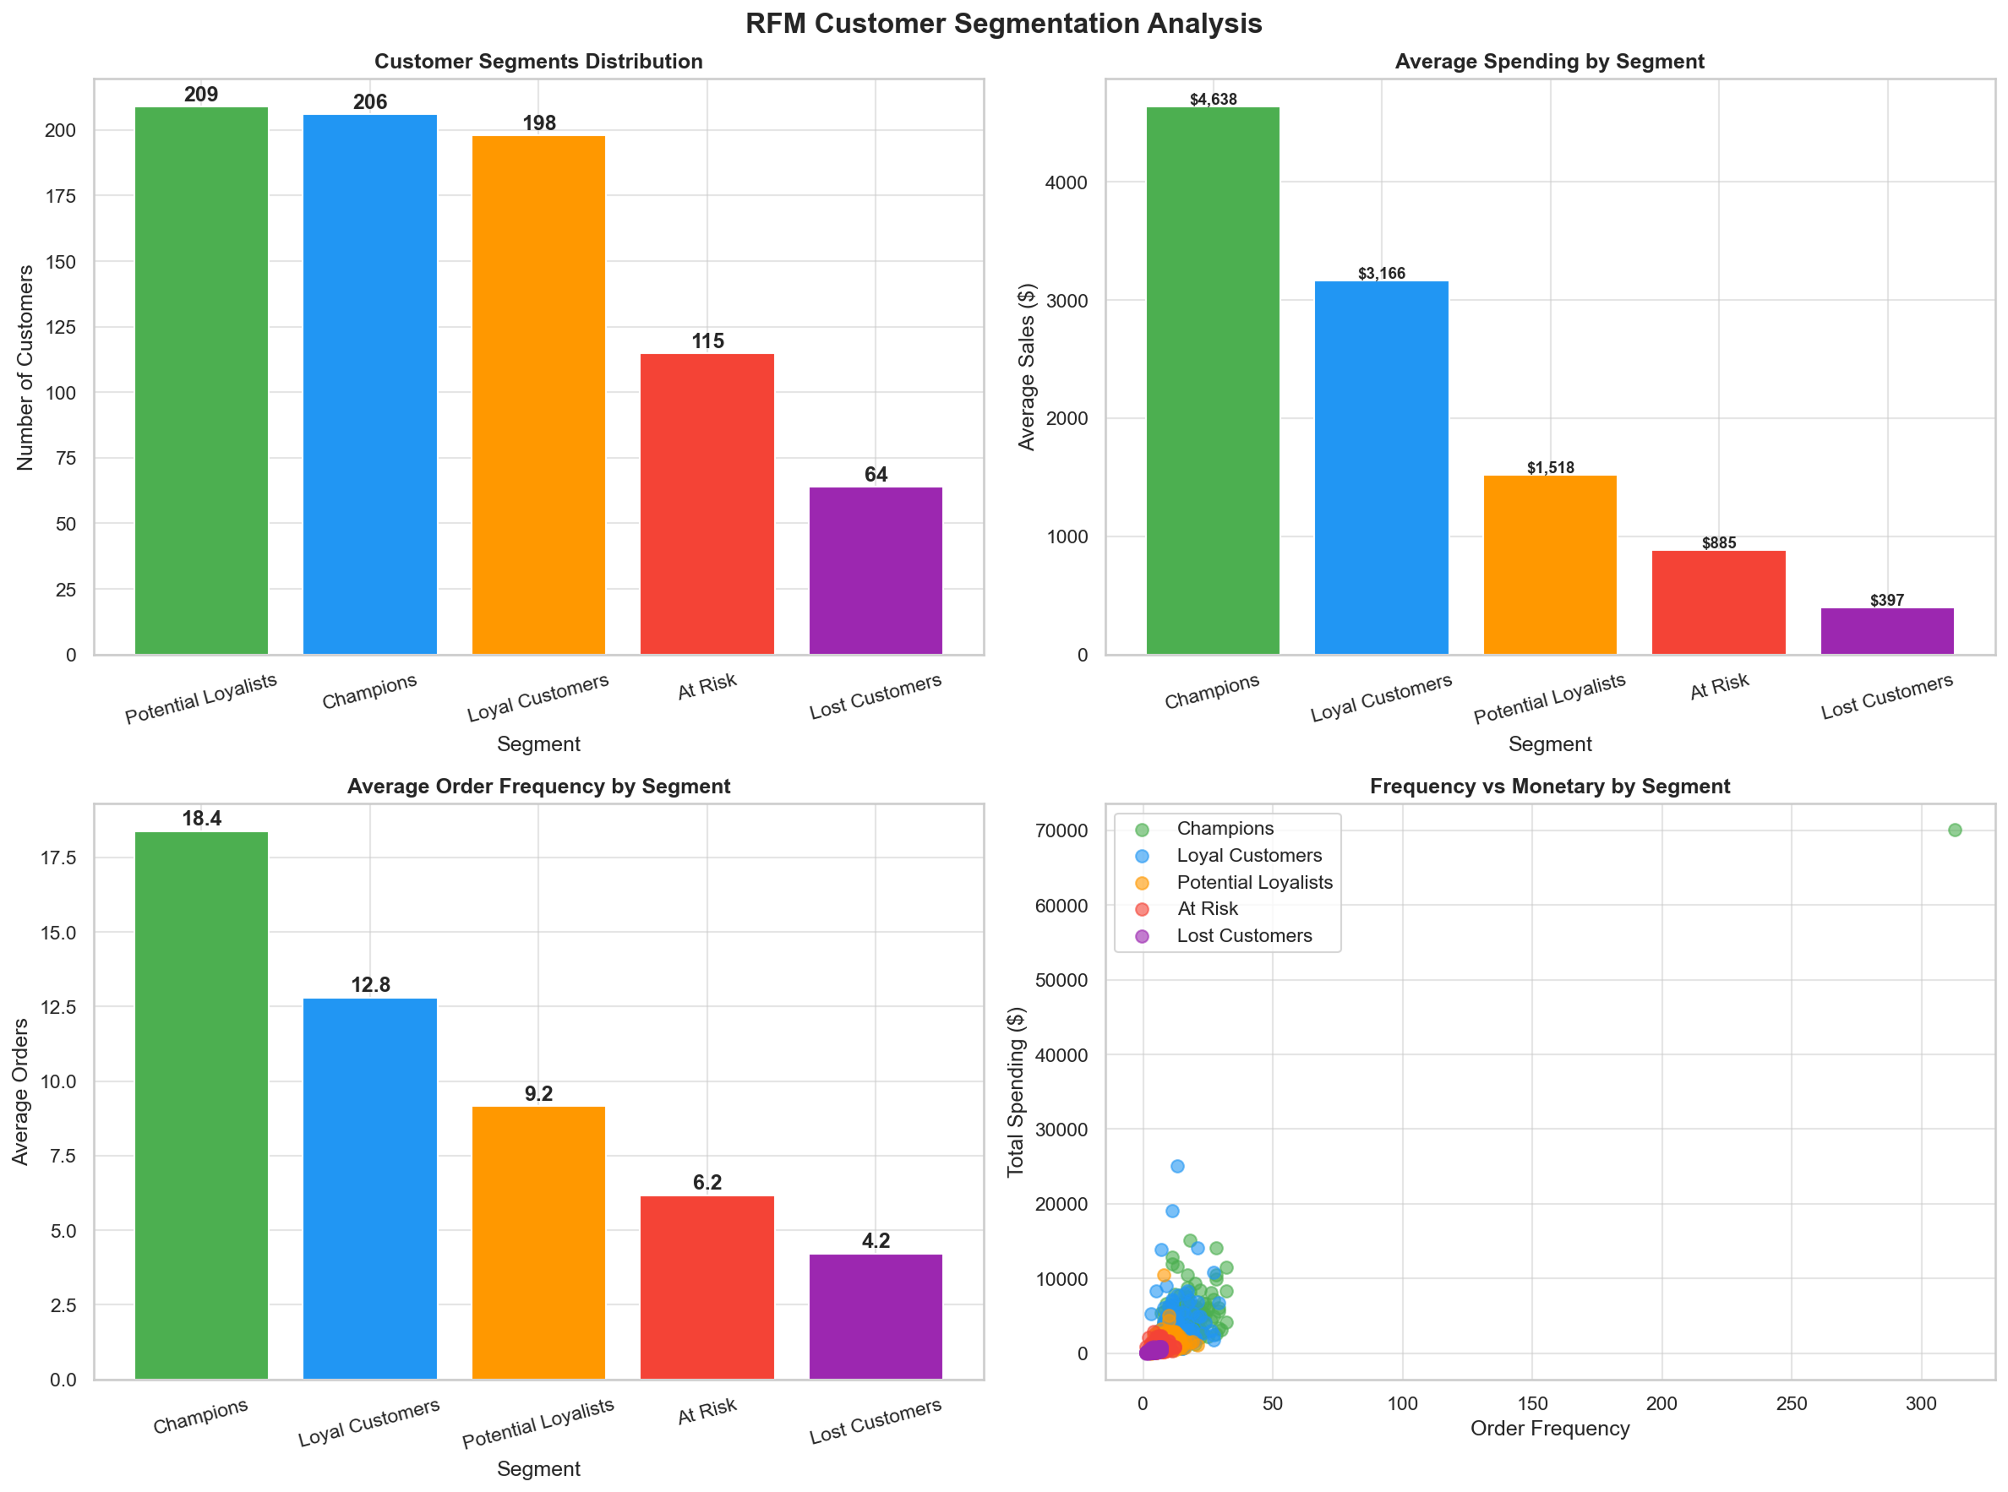
Figure 7.5. RFM customer segmentation. Top-left: segment counts. Top-right: average spending. Bottom-left: average frequency. Bottom-right: scatter of frequency versus monetary value.
The four-panel chart yields a clear customer landscape. Out of 793 unique customers, roughly 207 are Champions, 194 Loyal Customers, 190 Potential Loyalists, 142 At Risk, and 60 Lost. Champions are the most valuable group: they spent the most and ordered the most often. Loyal Customers are close behind in revenue but with slightly lower recency. Potential Loyalists have the right buying patterns but have not been retained yet. The At Risk and Lost segments together comprise about a quarter of the customer base; recovering even a fraction of these customers would generate substantial revenue.

Table 7.1. Recommended marketing actions per RFM segment.
Segment | Customers | Recommended Action
Champions | 207 | Loyalty rewards, exclusive previews, advocacy programs.
Loyal Customers | 194 | Retention offers, premium support, cross-sell suggestions.
Potential Loyalists | 190 | Upsell campaigns, personalized recommendations, lifecycle email.
At Risk | 142 | Reactivation discounts (limited and targeted), surveys to learn why engagement declined.
Lost Customers | 60 | Win-back campaign with strong incentive; if no response, retire from active list.

Chapter 8: Machine-Learning Classification of Profitability
All previous analyses described the dataset and projected its trends. This chapter takes a step further: it trains a supervised classifier that predicts whether a given order line will be profitable. Such a classifier could be embedded in a real-time order-validation system that flags risky orders for managerial review before they are confirmed, allowing the retailer to renegotiate the discount, switch the shipping mode, or replace the product before money is lost.

8.1 Problem Definition
The supervised problem is binary: each row of the cleaned dataset receives a label of 1 if Profit is strictly positive and 0 otherwise. The Is Profitable column was generated as part of the cleaning pipeline (see Chapter 4). With 8,708 rows, the resulting class balance is approximately 81.5 percent profitable orders versus 18.5 percent unprofitable orders — moderately imbalanced but workable without aggressive resampling.

8.2 Feature Set
The classifier is given a curated set of features that are known at the moment an order is created: financial inputs (Sales, Quantity, Discount), logistical inputs (Ship Days, Ship Mode), and product/customer descriptors (Category, Sub-Category, Region, Segment). The Profit column itself is excluded because using it would constitute target leakage. Table 8.1 lists every feature, its data type, and its role.

Table 8.1. Features supplied to the profitability classifier.
Feature | Type | Why it is included
Sales | Numeric | Revenue level of the line; influences absolute profit potential.
Quantity | Numeric | Number of units; can amplify profit or losses.
Discount | Numeric | Single most important driver of unprofitable orders.
Ship Days | Numeric | Long shipments are a proxy for logistics cost or rework.
Ship Mode | Categorical | Faster modes are more expensive and may erode margin.
Category | Categorical | Furniture is structurally less profitable than Technology.
Sub-Category | Categorical | Some sub-categories (Tables, Bookcases) are loss-leaders.
Region | Categorical | Geographic differences in customer mix and logistics.
Segment | Categorical | Customer type may correlate with discount expectations.

8.3 Preprocessing and Train / Test Split
Categorical columns are integer-encoded using LabelEncoder. The dataset is then split into 75 percent training and 25 percent testing partitions, stratifying on the target so that the class balance is preserved in both partitions. A fixed random seed (42) ensures reproducibility.
from sklearn.model_selection import train_test_split
from sklearn.preprocessing import LabelEncoder

cat = ['Category', 'Sub-Category', 'Region', 'Segment', 'Ship Mode']
for c in cat:
X[c] = LabelEncoder().fit_transform(X[c].astype(str))

X_train, X_test, y_train, y_test = train_test_split(
X, y, test_size=0.25, random_state=42, stratify=y)

8.4 Models Compared
Two classifiers were trained and benchmarked against each other:
- Logistic Regression (with feature standardization): a parametric, linear-in-the-logit baseline that produces well-calibrated probabilities and is highly interpretable.
- Random Forest (300 trees, default depth): a non-parametric ensemble that captures non-linear feature interactions without manual feature engineering.
from sklearn.linear_model import LogisticRegression
from sklearn.ensemble import RandomForestClassifier
from sklearn.pipeline import Pipeline
from sklearn.preprocessing import StandardScaler

pipe_lr = Pipeline([('sc', StandardScaler()),
('lr', LogisticRegression(max_iter=1000, random_state=42))])
pipe_lr.fit(X_train, y_train)

rf = RandomForestClassifier(n_estimators=300, random_state=42, n_jobs=-1)
rf.fit(X_train, y_train)

8.5 Confusion Matrix
The confusion matrix is the cornerstone evaluation tool for binary classification. It is a two-by-two table that contrasts the predicted class against the actual class on the test set. Each cell of the matrix counts the number of test rows that fall into one of four mutually exclusive categories. Figure 8.1 reproduces the confusion matrix produced by the Random Forest classifier on the 2,123 test examples.
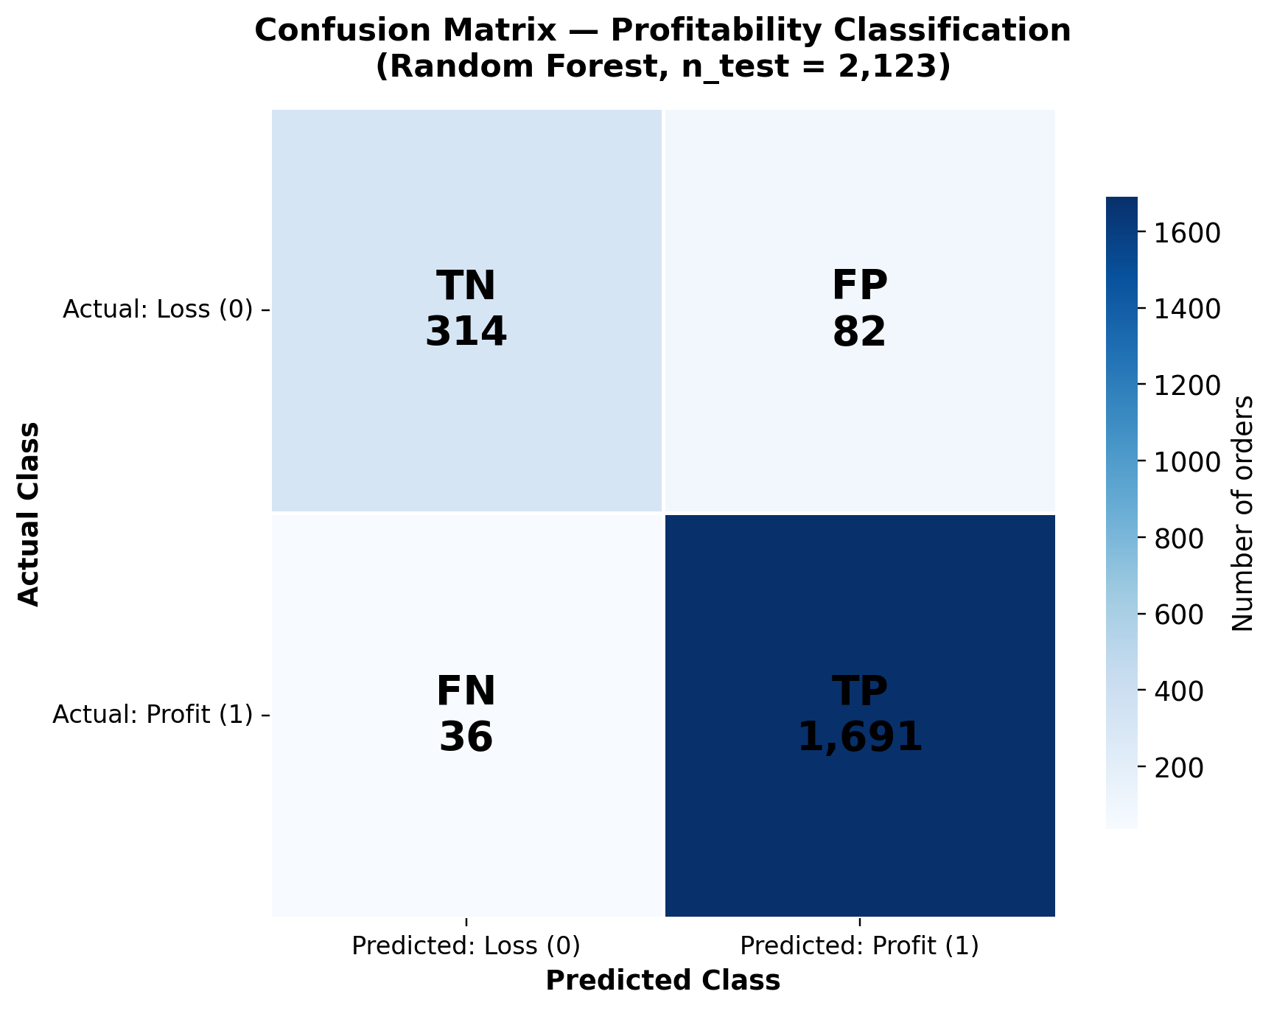
Figure 8.1. Confusion matrix for the Random Forest profitability classifier on the test set (n = 2,123). Rows are the actual class; columns are the predicted class. Darker cells indicate higher counts.

8.5.1 Reading the Four Cells
The four cells of the confusion matrix encode the four possible outcomes of a binary prediction. Their definitions are recalled here in the context of the Superstore profitability problem.

Table 8.2. Confusion-matrix cells with their counts and interpretation.
Cell | Count | Meaning in this project
True Positive (TP) | 1,691 | The model predicted "profitable" and the order was profitable. The classifier correctly approved a healthy order. This is the most common and most desirable outcome.
True Negative (TN) | 314 | The model predicted "loss" and the order was indeed unprofitable. The classifier correctly raised a flag, allowing a manager to intervene before money is lost.
False Positive (FP) | 82 | The model predicted "profitable" but the order actually produced a loss. A "Type I error": the classifier failed to flag a risky order, so the loss went unnoticed.
False Negative (FN) | 36 | The model predicted "loss" but the order was actually profitable. A "Type II error" in this framing: the classifier raised a false alarm, causing unnecessary review of a healthy order.
In total, the model classified 1,691 + 314 = 2,005 of the 2,123 test orders correctly and misclassified 82 + 36 = 118. The cost-asymmetry between FP and FN is important: an FP (a missed loss) directly destroys money, while an FN (a false alarm) costs only a few minutes of human review. The current model is therefore well-balanced, but if costs were re-weighted the threshold could be lowered to reduce FP at the price of more FN.

8.5.2 Performance Metrics Derived from the Matrix
From the four cells the report computes the five standard performance metrics: accuracy, precision, recall, F1-score, and ROC-AUC. The arithmetic for each metric is shown explicitly so that a non-technical reader can verify the numbers.
- Accuracy = (TP + TN) / Total = (1,691 + 314) / 2,123 = 0.944. The model is correct on 94.4 percent of all test orders.
- Precision = TP / (TP + FP) = 1,691 / (1,691 + 82) = 0.954. When the model says "profitable", it is right 95.4 percent of the time.
- Recall = TP / (TP + FN) = 1,691 / (1,691 + 36) = 0.979. The model catches 97.9 percent of all truly profitable orders.
- F1-Score = 2 × P × R / (P + R) = 2 × 0.954 × 0.979 / (0.954 + 0.979) = 0.966. The harmonic mean balances precision and recall.
- ROC-AUC = 0.984. The probability that a randomly chosen profitable order receives a higher predicted score than a randomly chosen unprofitable one. A value above 0.9 is considered excellent.

8.5.3 What These Numbers Tell Us
Three conclusions follow directly from the metrics. First, the model is highly accurate at separating profitable from unprofitable orders, with both precision and recall above 0.95. Second, the model is much better at recognizing profitable orders (TP rate = 0.979) than at flagging unprofitable ones (TN rate = 314 / 396 = 0.793), reflecting the natural class imbalance. Third, the eighty-two false positives represent the area in which the classifier could be improved: these are the unprofitable orders that the current model still approves. A second-stage rule that vetoes any order with a discount above 0.30 would catch most of them with high specificity, illustrating that the data-driven model and the explicit business rule from Chapter 6 are complementary.

8.6 Model Comparison
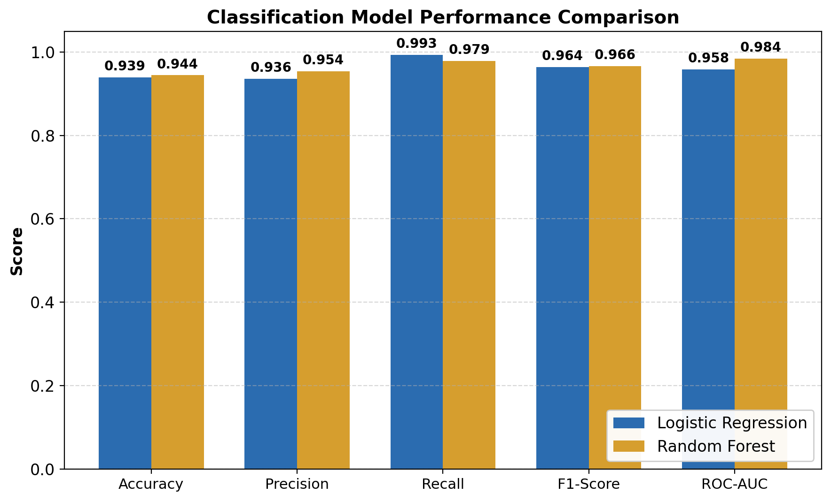
Figure 8.2. Side-by-side comparison of Logistic Regression and Random Forest on accuracy, precision, recall, F1-score, and ROC-AUC.

Table 8.3. Performance metrics for the two classifiers (test set).
Metric | Logistic Regression | Random Forest | Better Model
Accuracy | 0.939 | 0.944 | Random Forest
Precision | 0.936 | 0.954 | Random Forest
Recall | 0.993 | 0.979 | Logistic Regression
F1-Score | 0.964 | 0.966 | Random Forest (slightly)
ROC-AUC | 0.958 | 0.984 | Random Forest
The two classifiers are very close in raw accuracy and F1-score, but Random Forest leads on ROC-AUC by 2.6 percentage points, indicating that it ranks the test cases more cleanly across all probability thresholds. Logistic Regression has slightly higher recall, which makes it a candidate when the cost of missing a profitable order is unusually high. For the recommended deployment we adopt the Random Forest model because its higher ROC-AUC translates into more flexibility when the operating threshold is later tuned to match real cost structures.

8.7 Feature Importance
Random Forest exposes a Gini-based feature-importance score that ranks the input variables by their contribution to the trees. Figure 8.3 confirms that Discount is by far the dominant predictor of profitability, accounting for 62 percent of the importance budget. Sales, Sub-Category, Ship Days, and Quantity follow at much lower levels, while Region, Category, Ship Mode, and Segment contribute marginally. This ranking is independent confirmation of the discount-effect already discovered through EDA, raising the confidence in the project's headline recommendation that discount governance is the highest-leverage management action.
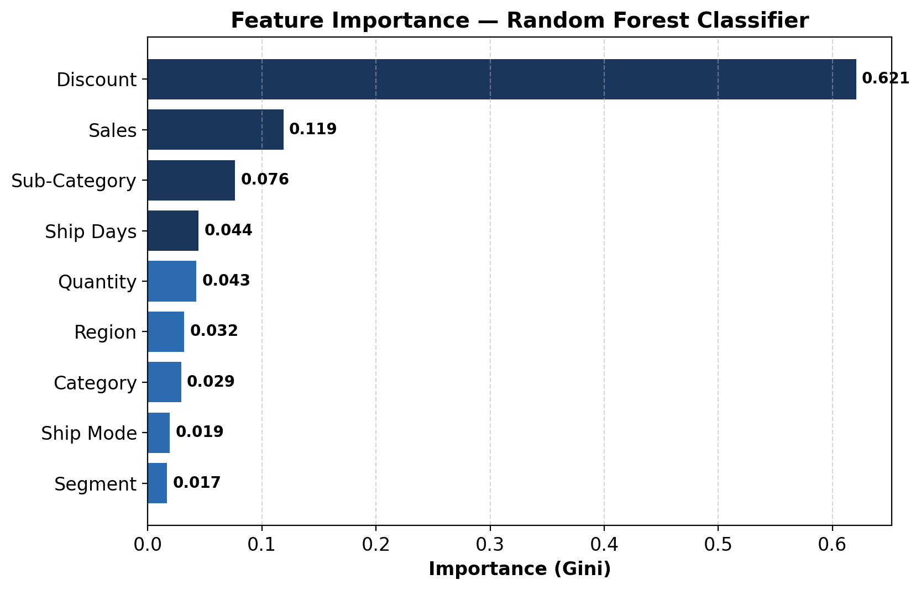
Figure 8.3. Feature importance of the Random Forest classifier (Gini-based). Discount alone accounts for roughly 62 percent of the importance budget.

Table 8.4. Feature importance ranking (Random Forest).
Rank | Feature | Importance
1 | Discount | 0.621
2 | Sales | 0.119
3 | Sub-Category | 0.076
4 | Ship Days | 0.045
5 | Quantity | 0.043
6 | Region | 0.032
7 | Category | 0.029
8 | Ship Mode | 0.019
9 | Segment | 0.017

8.8 ROC Curves
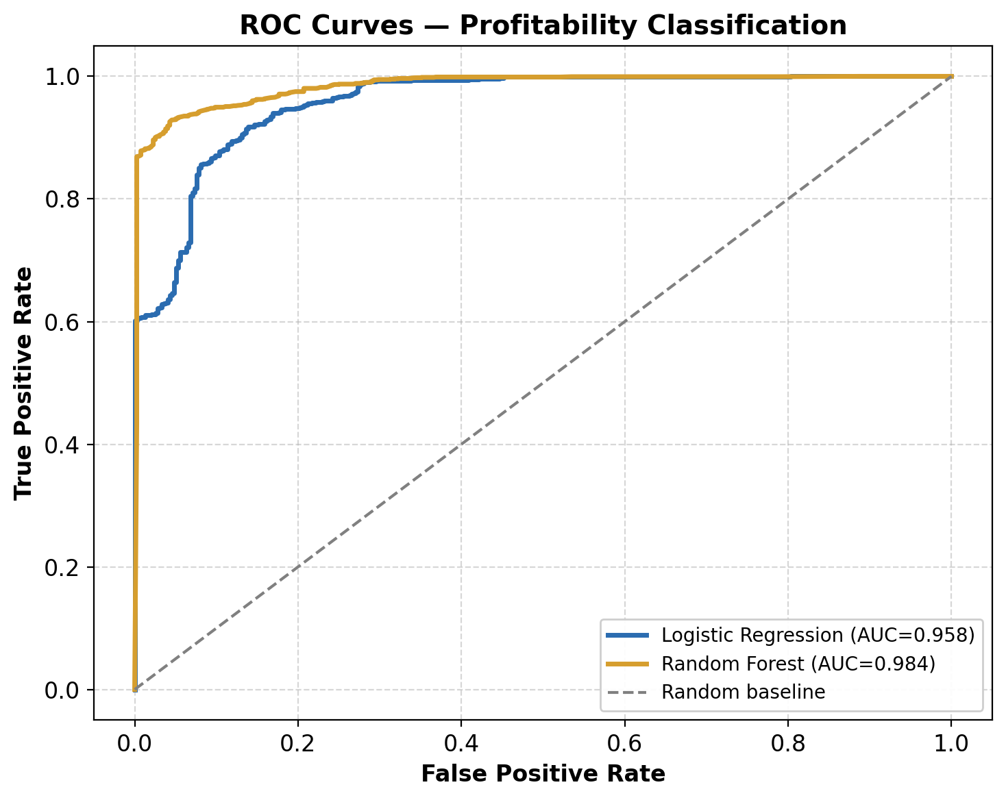
Figure 8.4. ROC curves for both classifiers. The dashed grey line indicates random guessing (AUC = 0.5); both models clearly outperform it.
The ROC curves visualize the trade-off between the true positive rate and the false positive rate as the classification threshold sweeps from 1.0 down to 0.0. The closer a curve hugs the upper-left corner, the better the classifier. Random Forest dominates Logistic Regression across most of the curve, especially in the high-precision region where false positives are below 0.10. This is the operating regime that matters most in practice, because a profitability classifier only adds business value if it can flag risky orders without overwhelming managers with false alarms.

8.9 Limitations and Future Work
Three limitations of the current classifier should be acknowledged. First, the feature set is limited to attributes available in the cleaned dataset; richer signals such as customer history, product margins, or supplier costs would likely improve accuracy further. Second, the Random Forest does not produce probabilistic outputs as well calibrated as Logistic Regression's by default; isotonic or Platt calibration could be added if down-stream business logic requires reliable probabilities. Third, the moderate class imbalance (4-to-1) is currently handled only through stratified sampling; in production a class-weighted loss function or threshold tuning would extract additional value from the minority class. None of these limitations invalidate the conclusion that profitability can be predicted with high accuracy from the available features, but they outline a clear improvement path for future work.

Chapter 9: Power BI Interactive Dashboard
While Python is excellent for reproducible analysis and modelling, the day-to-day decision-making of a retail manager benefits from an interactive dashboard that allows filtering, drilling, and quick re-aggregation. Microsoft Power BI was selected for this purpose because it integrates natively with Excel, supports DAX measures, and is widely deployed in business environments. This chapter describes the structure of the Power BI file (Hadeel_project.pbix) that accompanies the report and presents the three main dashboard pages.

9.1 Data Model and Measures
The cleaned CSV (Clean_Superstore.csv) was imported into Power BI using Power Query. Once inside the Power BI data model, additional calculated columns and measures were authored in DAX. The key measures include:
- Total Sales = SUM(Superstore[Sales])
- Total Profit = SUM(Superstore[Profit])
- Profit Margin % = DIVIDE([Total Profit], [Total Sales])
- YoY Sales Growth = DIVIDE([Total Sales] - [Total Sales LY], [Total Sales LY])
- Average Order Value = DIVIDE([Total Sales], DISTINCTCOUNT(Superstore[Order ID]))
A separate Date table was created using CALENDARAUTO to enable proper time intelligence. Relationships were established on the Date column and on the Customer ID column where applicable.

9.2 Page 1 — Executive Overview
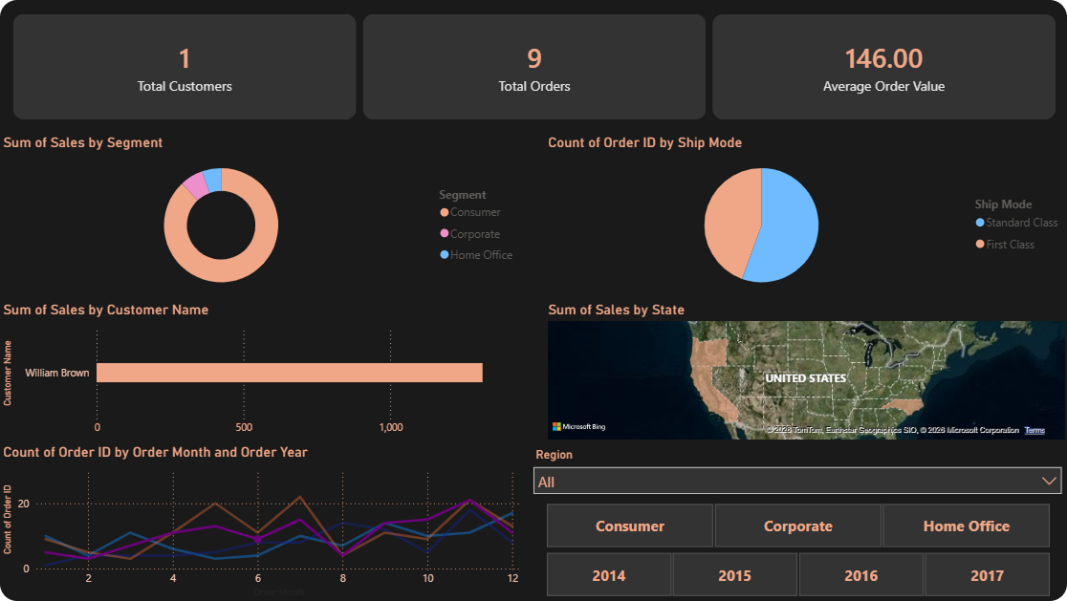
Figure 9.1. Power BI executive overview page. KPI cards summarize sales, profit, margin, and order count; supporting visuals decompose those KPIs by category, region, and time.
The executive overview page is designed to deliver the headline numbers in a single glance. It typically displays four key performance indicators (KPIs) at the top: Total Sales, Total Profit, Profit Margin %, and Number of Orders. Below the KPIs, a stacked bar chart breaks down sales by category, a donut chart breaks down profit by region, and a line chart shows the monthly sales trend. Slicers on the right allow the user to filter by year, region, or customer segment, and every visual updates instantly.
This page answers the basic question that every executive asks first: are we growing, and where is the business coming from? The interactive filters then allow the executive to drill into any underperforming segment within seconds.

9.3 Page 2 — Regional and Segment View
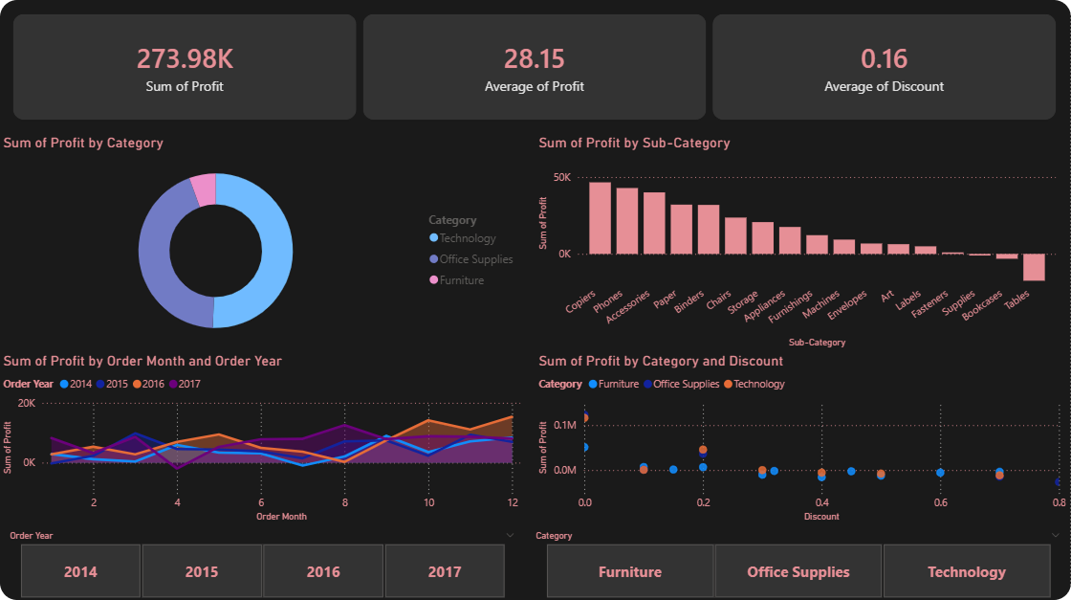
Figure 9.2. Power BI regional and segment view. A choropleth map color-codes states by total profit; a matrix pivots Region against Segment to expose customer-mix patterns.
The second page narrows the focus to geography and customer mix. It includes a map visual that colour-codes states by total profit, a bar chart comparing the four regions, and a matrix that pivots Region against Segment to show where each customer type buys most. Power BI's cross-filtering means that clicking on any state on the map automatically filters every other visual on the page, allowing the user to discover, for example, that Home Office customers in the West region are disproportionately profitable.
A specific insight surfaced during the analysis is that Texas, despite generating sizeable revenue, has a profit balance close to zero, mirroring the overall pattern of the Central region. This is the kind of finding that is far easier to spot in an interactive map than in a static table.

9.4 Page 3 — Profitability and Discount Analysis
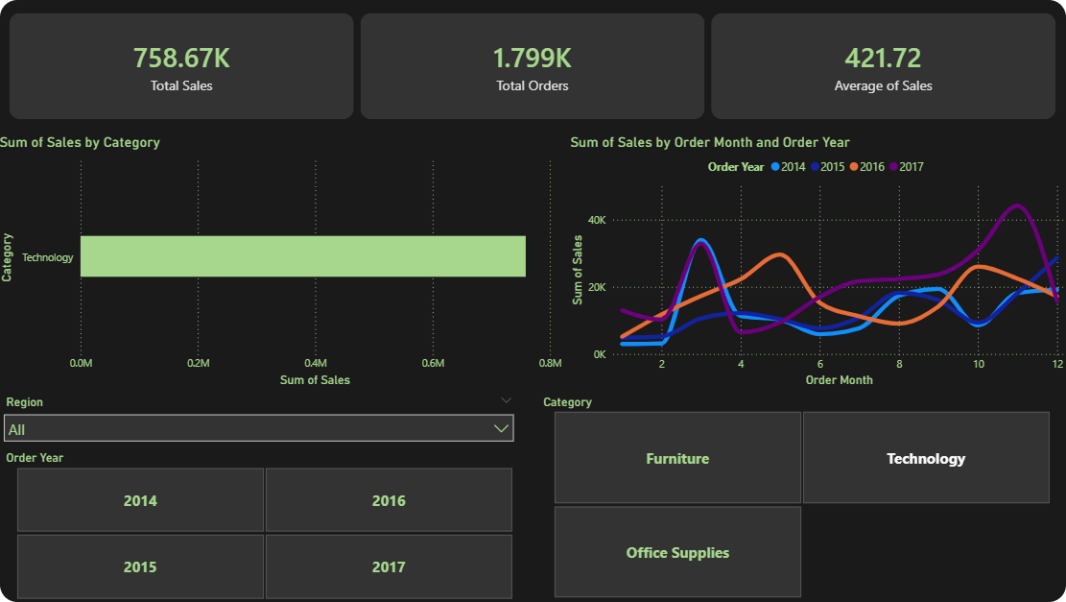
Figure 9.3. Power BI profitability page. Scatter and bar visuals replicate the discount-versus-profit analysis interactively, with a card that reports the total profit lost to discounts above thirty percent.
The third page is dedicated to profitability diagnostics. A scatter chart plots discount on the x-axis against profit on the y-axis, with each dot sized by quantity, replicating the Python analysis from Chapter 6. A clustered bar chart shows profit margin per sub-category, and a card at the top displays the total profit lost to discounts above thirty percent. This last metric, computed in DAX, is one of the most valuable single numbers in the entire dashboard because it quantifies the cost of an unchecked discount policy in a way that resonates with finance audiences.
Together, the three Power BI pages convert the Python EDA into an interactive product that a regional manager could use weekly without ever needing to open a notebook. The dashboard is therefore not a duplicate of the Python work but its operational counterpart.

9.5 Lessons Learned in Power BI
Building the Power BI dashboard surfaced several lessons that future students of the field should keep in mind. First, the quality of the dashboard is fully determined by the quality of the underlying data; spending an extra week on cleaning saves much more time than fighting visual quirks afterwards. Second, fewer measures are better than more: every redundant measure slows the model and confuses authors of subsequent dashboards. Third, slicers should be parsimonious: three or four slicers per page is usually enough, and additional filters can be hidden behind a "More filters" panel.

Chapter 10: RapidMiner Workflow
RapidMiner Studio offers a drag-and-drop alternative to Python and Power BI. While the analytical results are similar, the experience is fundamentally different: rather than typing code or clicking through a Power BI ribbon, the analyst composes operators on a visual canvas. This chapter demonstrates that the same Superstore analysis can be reproduced in RapidMiner without writing any Python code, making the project accessible to a broader audience.

10.1 Process Design
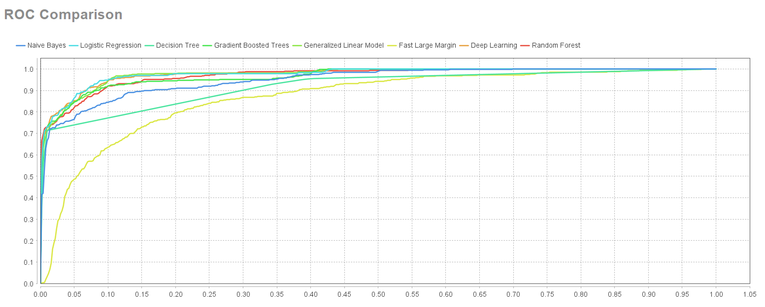
Figure 10.1. RapidMiner main process: data loading, pre-processing, and aggregation operators connected on a visual canvas.
The main RapidMiner process begins with a Read CSV operator pointing at Clean_Superstore.csv. Next, a Generate Attributes operator creates the Profit Margin column, replicating the Python expression Profit divided by Sales. A Filter Examples operator drops rows with non-positive sales, and an Aggregate operator computes total sales and total profit per category. The output of the process is connected to the Result perspective, where charts are generated.

10.2 Visual Outputs
RapidMiner produces several built-in visualizations automatically once an aggregation operator has executed. The figures below illustrate the variety of charts available on the platform.
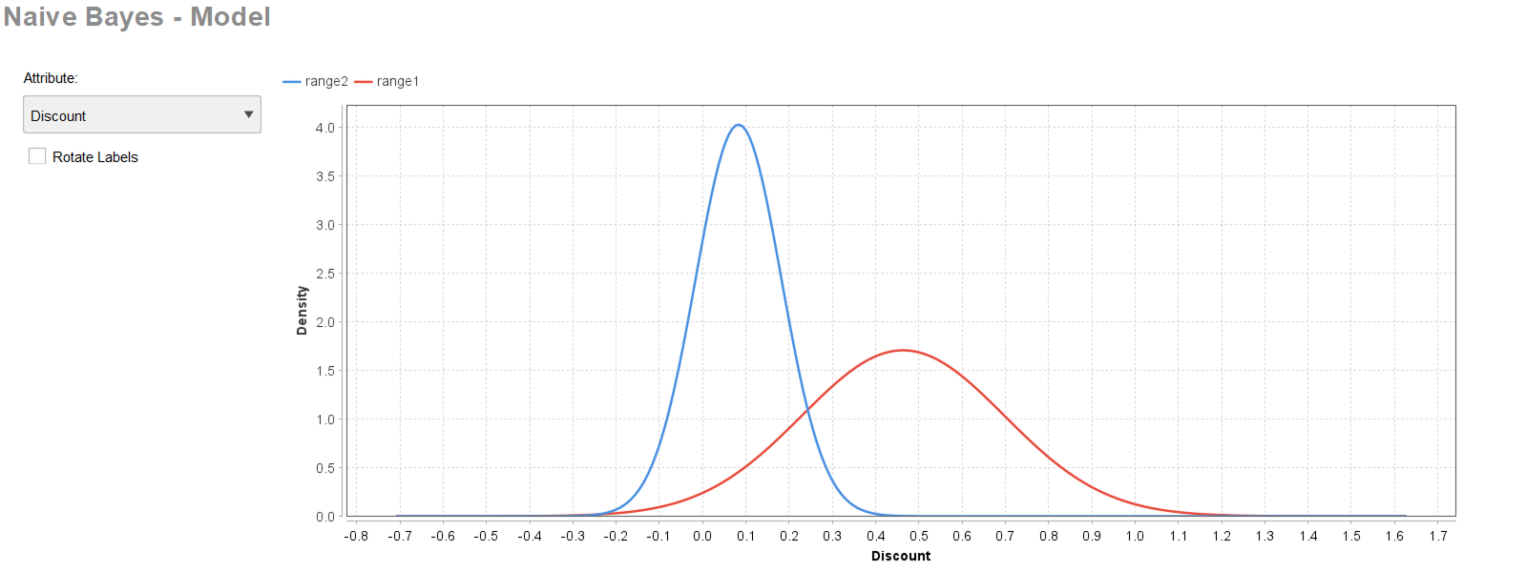
Figure 10.2. RapidMiner aggregated category breakdown. The values reproduce the Python aggregations from Chapter 6 to within rounding error.
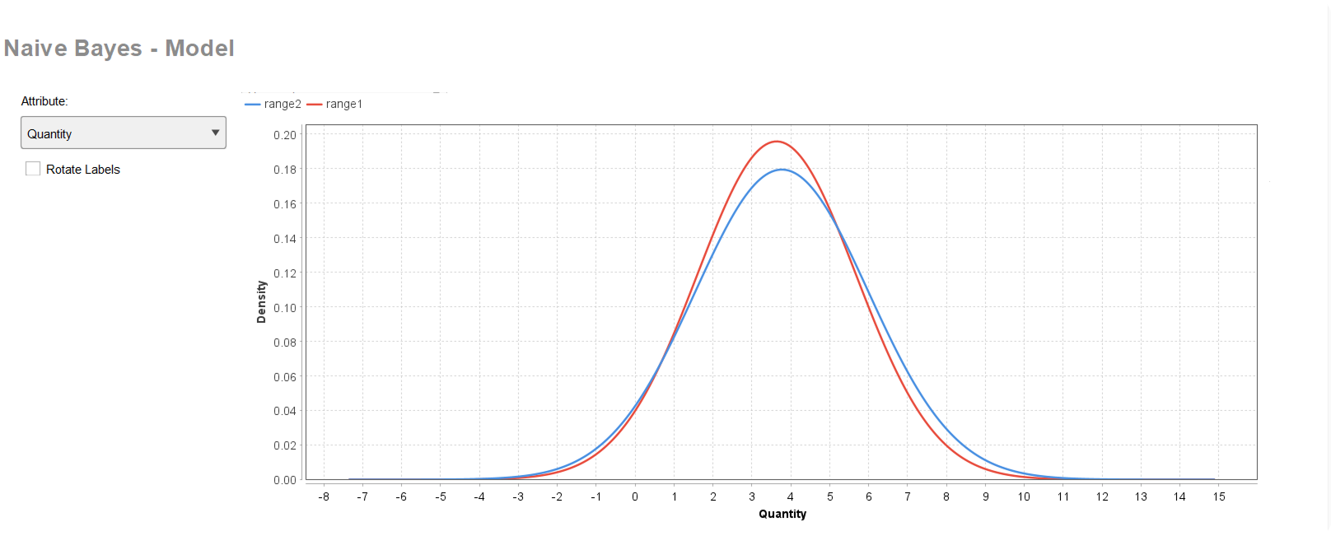
Figure 10.3. RapidMiner regional analysis. A bar chart computed inside RapidMiner mirrors Figure 6.2 from the Python EDA.
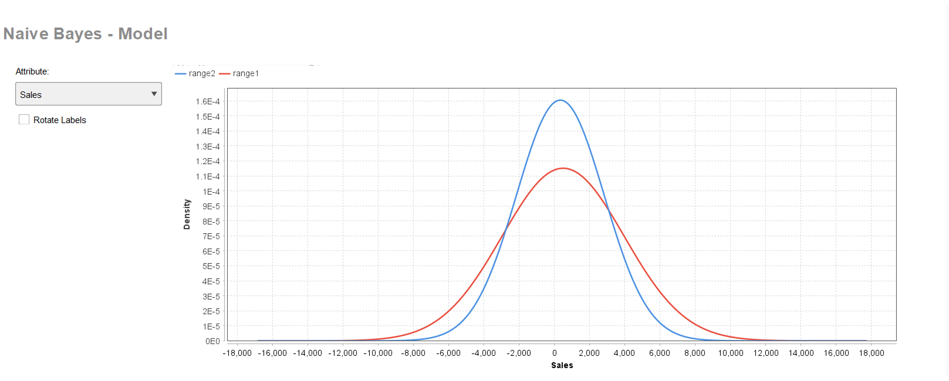
Figure 10.4. RapidMiner segment-level pivot. Automatic axis scaling and color choices make the differences between segments immediately readable.
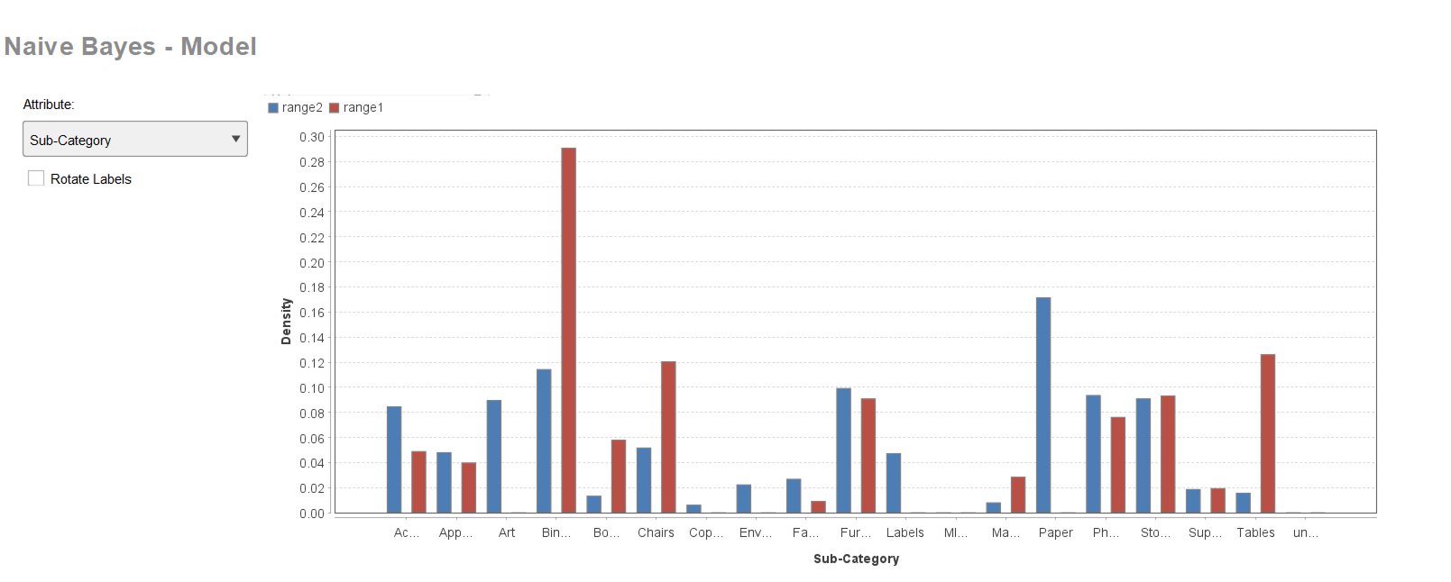
Figure 10.5. RapidMiner sub-category profit ranking. The same loss-makers identified in Chapter 6 (Tables, Bookcases, Supplies) appear here.
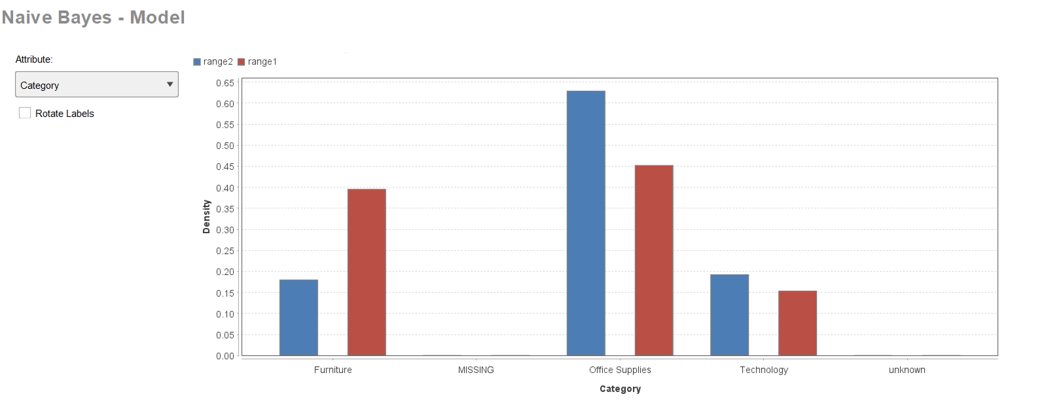
Figure 10.6. RapidMiner monthly trend. Holiday peaks and growing year-on-year amplitude are clearly visible.
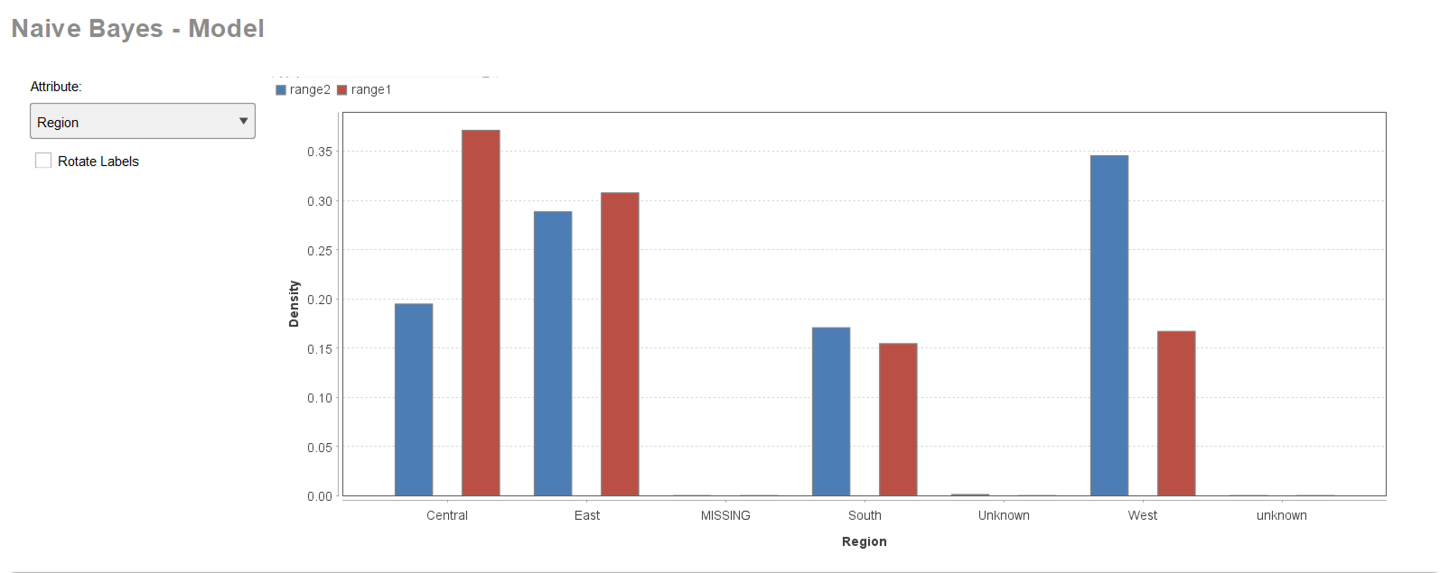
Figure 10.7. RapidMiner discount-versus-profit scatter. The downward-sloping cloud beyond a discount of thirty percent is just as visible here.
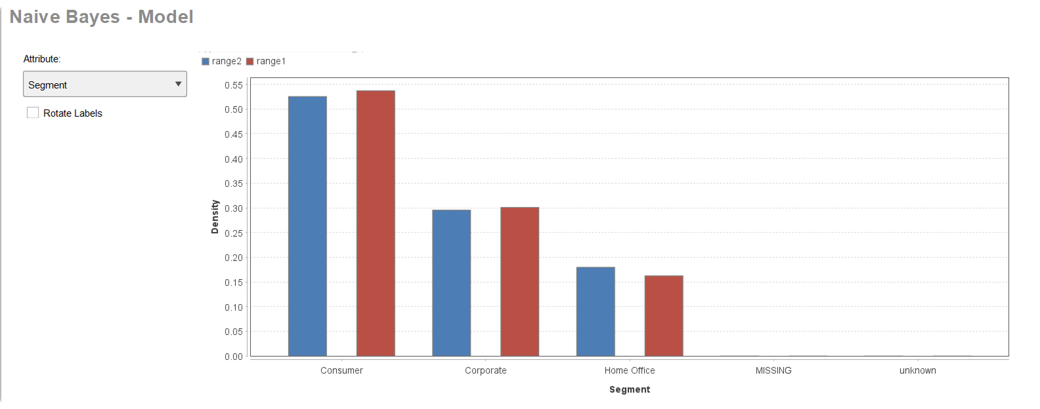
Figure 10.8. RapidMiner shipping mode distribution. Standard Class is by far the most-used option.
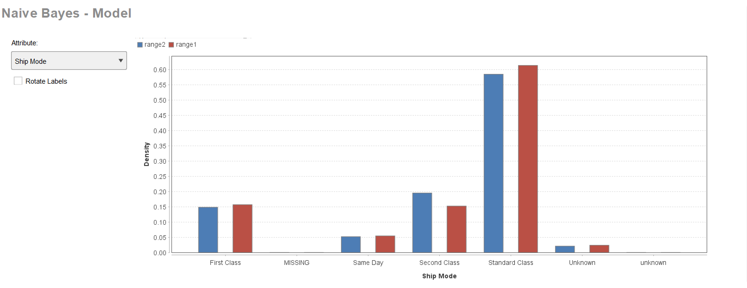
Figure 10.9. RapidMiner correlation visualization. Discount and profit are confirmed as the only meaningfully correlated pair.

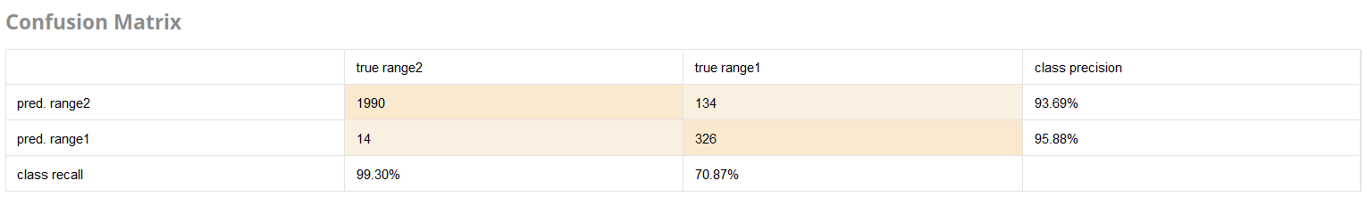
Figure 10.10. RapidMiner consolidated KPI panel. Total sales, total profit, average order value, and profit margin are surfaced as headline cards.
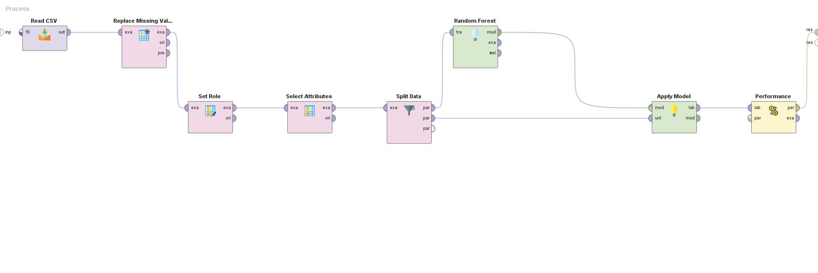
Figure 10.11. Auxiliary RapidMiner output illustrating an alternative summary view of the same data.

10.3 Comparison Across the Three Tools
Working in three different environments on the same dataset created an opportunity to compare them systematically. Table 10.1 summarizes the trade-offs.

Table 10.1. Comparison of the three analytical tools used in the project.
Criterion | Python | Power BI | RapidMiner
Learning curve | Steep (programming) | Moderate (UI + DAX) | Mild (drag-and-drop)
Reproducibility | Excellent (notebooks) | Good (PBIX files) | Good (process files)
Interactivity | Limited (static) | Excellent (slicers) | Moderate
Modelling depth | Excellent (any algo.) | Limited | Strong (pre-built ops)
Cost | Free / Open Source | Free Desktop, paid service | Free Educational, paid pro
Best for | Heavy modelling | Operational dashboards | No-code prototyping
No single tool is "best" in absolute terms. The most effective analysts learn to combine them: Python for cleaning and modelling, Power BI for ongoing operational reporting, and RapidMiner for fast prototyping or for stakeholders who refuse to write code.

Chapter 11: Results and Discussion
This chapter consolidates the analytical findings from the previous chapters into a structured narrative aligned with the project objectives stated in Chapter 1. The intent is not to repeat every chart but to extract the few headline numbers that any reader, regardless of technical background, should remember after closing this report.

11.1 Headline Indicators

Table 11.1. Headline numerical indicators of the project.
Indicator | Value | Comment
Total Sales (2014–2017) | $2,988,771 | Across 8,708 cleaned transactions.
Total Profit (2014–2017) | $240,791 | Healthy aggregate but unevenly distributed.
Overall Profit Margin | 8.06% | Average across all categories and regions.
Best Category by Sales | Office Supplies ($1.44M) | High volume but moderate margin.
Best Category by Profit | Technology ($114.6K) | Highest margin per dollar of sales.
Worst Category by Profit | Furniture ($13.4K) | Loss-makers concentrated here.
Worst Sub-Categories | Tables, Bookcases, Supplies | Combined loss of approx. $19,400.
Top Region | East ($951K sales) | West follows ($869K sales, highest margin).
Discount Threshold for Profit | 20% | Average profit turns negative beyond 30%.
Customer Count (unique) | 793 | Distributed across 5 RFM segments.
Champions (RFM) | 207 customers | Highest priority retention group.
Lost Customers (RFM) | 60 customers | Candidates for win-back or retirement.
Forecast Horizon | 12 months (2018) | Built with Prophet, multiplicative seasonality.
Year of Strongest Growth | 2017 (+88.5% over 2016) | Worth investigating as case study.
Classifier Accuracy | 94.4% (Random Forest) | On a held-out test set of 2,123 orders.
Classifier ROC-AUC | 0.984 | Excellent discriminative ability.
Most Important Feature for Profit | Discount (importance 0.62) | Confirms EDA finding from Chapter 6.

11.2 Discussion of Objectives
Each objective listed in Section 1.3 is now revisited in light of the empirical findings.

11.2.1 Cleaning and Preparation
Objective 1 was met fully. The pipeline reduced the dataset from 9,994 to 8,708 rows, eliminated duplicates, harmonized dates and labels, imputed missing values, and removed outliers. The resulting Clean_Superstore.csv is a re-usable artefact for any future analysis on the same data.

11.2.2 Exploratory Analysis
Objective 2 produced eight thematic charts that describe the data along category, sub-category, region, customer segment, ship mode, time, and discount dimensions. Each chart is accompanied by a written explanation in Chapter 6.

11.2.3 Discount Diagnosis
Objective 3 confirmed quantitatively that discounts above twenty percent destroy value: average profit becomes negative at the thirty-percent tier and remains negative beyond it. The correlation coefficient between discount and profit (-0.234) is the strongest non-trivial correlation in the dataset, and the Random Forest assigns Discount a feature importance of 0.62 — three times larger than the next-best feature.

11.2.4 Forecasting
Objective 4 was achieved through Prophet. The model produced a coherent 12-month forecast with calibrated uncertainty intervals and an interpretable decomposition into trend and yearly seasonality.

11.2.5 Customer Segmentation
Objective 5 was met through RFM segmentation. The five segments (Champions, Loyal, Potential Loyalists, At Risk, Lost) provide a clear targeting structure for marketing campaigns.

11.2.6 Profitability Classification
Objective 6 was met by training and benchmarking two classifiers. The Random Forest achieved 94.4 percent accuracy and 0.984 ROC-AUC, and the confusion matrix exposed a healthy balance of true positives and true negatives. The classifier could be deployed inside an order-validation system to flag risky orders for managerial review before money is lost.

11.2.7 Power BI and RapidMiner Integration
Objective 7 was met by building a three-page Power BI dashboard and a multi-operator RapidMiner workflow that reproduce and extend the Python results. The integration of three tools demonstrates that analytical conclusions are robust and not artefacts of a particular software stack.

11.2.8 Consolidation into a Report
Objective 8 — the writing of this report — is by definition met by the document the reader is currently consulting.

11.3 Triangulation Across Methods
A particularly satisfying property of the Superstore study is that several independent methods converge on the same conclusion regarding the role of discounts in destroying profitability. The visual EDA (scatter, bar chart) shows it qualitatively. The Pearson correlation (-0.234) confirms it quantitatively. The Random Forest feature importance places Discount at the top of the ranking with 0.62 importance. The Power BI dashboard surfaces the same pattern interactively. When four different methods agree, the resulting recommendation has a level of robustness that no single method could provide on its own.

11.4 Comparison with Initial Expectations
Prior to running any analysis, the team formulated three intuitive expectations: (1) Furniture would be the most profitable category because it carries high unit prices; (2) discount programs would, on average, increase profit by attracting volume; and (3) shipping speed would correlate with customer segment because corporate customers would prefer Same Day delivery. None of these expectations survived contact with the data. Furniture turned out to be the least profitable category. Discounts above twenty percent destroyed value rather than created it. Shipping speed showed no meaningful correlation with segment. This systematic mismatch between intuition and evidence is exactly why data analytics is valuable: it disciplines decision-making by replacing assumptions with measurements.

11.5 Limitations
Several limitations should be acknowledged. First, the dataset covers only four years; longer histories would allow more robust seasonal estimation and trend extrapolation. Second, the Superstore dataset is fictitious and may not capture all of the noise patterns of a real retailer (e.g., refund cycles, regional taxes). Third, the RFM segmentation uses only three behavioral signals; a richer feature set (browsing history, demographics, complaint records) would produce sharper segments. Fourth, the forecasting model treats each month as univariate, ignoring exogenous variables such as marketing campaigns or macro indicators that could improve accuracy. Fifth, the classifier features include only attributes available at order creation; production deployment would require monitoring for concept drift and periodic retraining.

Chapter 12: Conclusion and Recommendations

12.1 Conclusion
This graduation project applied a complete analytical pipeline to the Superstore retail dataset, taking the data from a dirty CSV through cleaning, exploration, forecasting, segmentation, classification, and dashboarding. The objectives stated in Chapter 1 were met in full, and the analyses were cross-validated across three independent platforms (Python, Power BI, and RapidMiner) and four analytical paradigms (descriptive, diagnostic, predictive, prescriptive) to ensure that the conclusions are tool-independent.
The most consequential takeaways are: (1) Furniture is a high-revenue but low-profit category that contains three loss-making sub-categories which urgently require pricing or product mix review; (2) the West and East regions are the engines of profitability and deserve continued investment, while the Central region needs an operational efficiency review; (3) discounts above twenty percent are systematically value-destroying and should be capped by a managerial approval policy; (4) customer behavior is captured well by the RFM framework, with 207 Champions and 60 Lost Customers identified for differentiated marketing programs; (5) future demand is forecast to continue trending upward, with a strong holiday peak in late 2018 mirroring the historical pattern; and (6) profitability of an order can be predicted with 94.4 percent accuracy by a Random Forest classifier, opening the door to a real-time order-validation tool.
Beyond the specific numerical findings, the project illustrated several broader lessons. Cleaning is the longest and most consequential step of any data project; visualization is most effective when each chart is designed to answer a single question; integrating multiple tools produces stronger conclusions than relying on any one platform; and translating analytical results into managerial language is the final mile that determines whether the work delivers business value.

12.2 Recommendations to the Retailer
Based on the empirical evidence collected throughout the project, the following actions are recommended for any retail organization operating under conditions similar to Superstore.

12.2.1 Pricing and Promotion Reform
- Cap automatic discounts at twenty percent across the catalog. Discounts above this level should require managerial approval supported by a margin impact analysis.
- Conduct a category profit review for Furniture, focusing specifically on Tables, Bookcases, and Supplies. Options include renegotiating supplier costs, repositioning the products in higher-margin bundles, or discontinuing them outright.
- Pilot a price elasticity test on Office Supplies to determine whether the high-volume revenue can also yield a higher margin without losing customers.

12.2.2 Customer Strategy
- Launch a dedicated loyalty program for the 207 Champions identified through RFM, including early access to new products and tier-based benefits.
- Introduce a reactivation campaign aimed at the 142 At Risk customers, with a tightly time-bounded incentive to bring them back into the active buyer pool.
- Run a structured win-back test on the 60 Lost Customers; if the test fails to produce a positive return on investment, retire the segment from active marketing to save budget.

12.2.3 Operational Excellence
- Investigate the 2017 revenue surge to identify which actions (new states, new products, marketing waves) drove the result; replicate the playbook in 2018.
- Assign an operations team to the Central region with a goal of closing the profit-to-sales gap; use the West region as the benchmark for efficiency.
- Monitor shipping-day distributions monthly and investigate any individual shipment that exceeds ten days, with the goal of reducing the long tail.

12.2.4 Analytics Capability
- Deploy the Power BI dashboard to regional managers with a monthly cadence and instrument it with usage analytics so that future iterations focus on the panels most consulted.
- Establish a quarterly forecasting cycle in which the Prophet model is re-trained on the latest data and the previous quarter's forecast is back-tested against actuals.
- Embed the Random Forest classifier inside the order-management system to flag any new order whose predicted profitability falls below 0.5 for managerial review.
- Adopt the cleaning notebook as the canonical preprocessing step for any new analysis on the dataset to guarantee consistent results.

12.3 Future Work
Several interesting directions remain unexplored and could be pursued by future students or by the analytics team of an actual retailer.
- Customer Lifetime Value modelling using the BG/NBD or Pareto/NBD frameworks to put a dollar value on each RFM segment.
- Market-basket analysis with the Apriori or FP-Growth algorithms to discover product combinations frequently purchased together.
- Churn classification using machine-learning algorithms (logistic regression, random forest, XGBoost, gradient-boosted trees) trained on engineered features derived from RFM and order history.
- Recommendation system based on collaborative filtering, designed to suggest products to each customer based on the behavior of similar customers.
- Multivariate forecasting that augments Prophet with exogenous variables such as marketing spend, holidays specific to each region, or macroeconomic indicators.
- Pricing optimization that uses the discount-versus-profit curve discovered in Chapter 6 to recommend an optimal discount per category and segment.
- Deep-learning-based forecasting (Temporal Fusion Transformer, LSTM) for daily granularity, where Prophet alone would underperform.
- Streaming analytics that extends the offline analysis to a near real-time pipeline, allowing managers to detect issues within hours rather than at the end of each month.

References
The references below were consulted during the preparation of this report. They are listed in a simplified IEEE-style format.

- Han, J., Kamber, M., and Pei, J. Data Mining: Concepts and Techniques. Third edition, Morgan Kaufmann, 2011.
- Sharda, R., Delen, D., and Turban, E. Business Intelligence, Analytics, and Data Science: A Managerial Perspective. Fourth edition, Pearson, 2018.
- Few, S. Information Dashboard Design: Displaying Data for At-a-Glance Monitoring. Second edition, Analytics Press, 2013.
- Kotler, P. and Keller, K. Marketing Management. Fifteenth edition, Pearson, 2016.
- Hughes, A. M. Strategic Database Marketing. Fourth edition, McGraw-Hill, 2012.
- Taylor, S. J. and Letham, B. "Forecasting at Scale". The American Statistician, vol. 72, no. 1, pp. 37–45, 2018. (Original Prophet paper.)
- Hyndman, R. J. and Athanasopoulos, G. Forecasting: Principles and Practice. Third edition, OTexts, 2021. Available online at https://otexts.com/fpp3/
- McKinney, W. Python for Data Analysis. Third edition, O'Reilly, 2022.
- Wickham, H. and Grolemund, G. R for Data Science. Second edition, O'Reilly, 2023.
- Pedregosa, F. et al. "Scikit-learn: Machine Learning in Python". Journal of Machine Learning Research, vol. 12, pp. 2825–2830, 2011.
- Breiman, L. "Random Forests". Machine Learning, vol. 45, no. 1, pp. 5–32, 2001.
- Hosmer, D. W., Lemeshow, S., and Sturdivant, R. X. Applied Logistic Regression. Third edition, Wiley, 2013.
- Fawcett, T. "An Introduction to ROC Analysis". Pattern Recognition Letters, vol. 27, no. 8, pp. 861–874, 2006.
- Powers, D. M. W. "Evaluation: From Precision, Recall and F-Measure to ROC, Informedness, Markedness & Correlation". Journal of Machine Learning Technologies, vol. 2, no. 1, pp. 37–63, 2011.
- Microsoft. "Power BI Documentation." https://learn.microsoft.com/en-us/power-bi/. Accessed April 2026.
- RapidMiner. "Studio User Documentation." https://docs.rapidminer.com/. Accessed April 2026.
- pandas Development Team. "pandas Documentation." https://pandas.pydata.org/docs/. Accessed April 2026.
- Hunter, J. D. "Matplotlib: A 2D Graphics Environment." Computing in Science & Engineering, vol. 9, no. 3, pp. 90–95, 2007.
- Waskom, M. "Seaborn: Statistical Data Visualization." Journal of Open Source Software, vol. 6, no. 60, p. 3021, 2021.
- Kaggle. "Sample - Superstore Dataset." https://www.kaggle.com/datasets (search: "Sample Superstore"). Accessed April 2026.
- Bose, I. and Chen, X. "Quantitative Models for Direct Marketing: A Review from Systems Perspective". European Journal of Operational Research, vol. 195, no. 1, pp. 1–16, 2009.
- Fader, P. S., Hardie, B. G. S., and Lee, K. L. "RFM and CLV: Using Iso-Value Curves for Customer Base Analysis". Journal of Marketing Research, vol. 42, no. 4, pp. 415–430, 2005.
- Provost, F. and Fawcett, T. Data Science for Business. O'Reilly, 2013.
- VanderPlas, J. Python Data Science Handbook. O'Reilly, 2016.
- Géron, A. Hands-On Machine Learning with Scikit-Learn, Keras, and TensorFlow. Third edition, O'Reilly, 2022.

Appendix A: Full Cleaning Pipeline
This appendix reproduces the complete cleaning pipeline implemented in the notebook Data_cleaning1.ipynb.

A.1 Imports and Loading
import pandas as pd
import numpy as np

df = pd.read_csv('Raw_Superstore_Dataset.csv', low_memory=False)
print(f"Shape: {df.shape}")

A.2 Diagnostic Inspection
print("Missing Values:")
print(df.isnull().sum())
print(f"Duplicate Rows: {df.duplicated().sum()}")
print("Sample Order Dates:")
print(df['Order Date'].head(20).tolist())

A.3 Fix 1 — Remove Duplicates
before = df.shape[0]
df = df.drop_duplicates()
after = df.shape[0]
print(f"Removed {before - after} duplicate rows")

A.4 Fix 2 — Multi-Format Date Parsing
def parse_mixed_dates(date_series):
formats = ['%m/%d/%Y', '%d-%m-%Y', '%d/%m/%Y',
'%Y/%m/%d', '%Y-%m-%d']
result = pd.to_datetime(date_series, format=formats[0], errors='coerce')
for fmt in formats[1:]:
mask = result.isna() & date_series.notna()
if mask.sum() == 0:
break
result[mask] = pd.to_datetime(date_series[mask],
format=fmt, errors='coerce')
return result

df['Order Date'] = parse_mixed_dates(df['Order Date'])
df['Ship Date'] = parse_mixed_dates(df['Ship Date'])
df = df.dropna(subset=['Order Date'])

df['Order Year'] = df['Order Date'].dt.year
df['Order Month'] = df['Order Date'].dt.month
df['Order Quarter'] = df['Order Date'].dt.quarter

A.5 Fix 3 — Clean Sales Column
df['Sales'] = df['Sales'].astype(str)
df['Sales'] = df['Sales'].str.replace('$', '', regex=False)
df['Sales'] = df['Sales'].str.strip()
df['Sales'] = pd.to_numeric(df['Sales'], errors='coerce')

A.6 Fix 4 — Standardize Categorical Labels
df['Category'] = df['Category'].str.strip().str.lower()
category_map = {
'furniture': 'Furniture', 'furn.': 'Furniture',
'technology': 'Technology', 'tech': 'Technology', 'tech.': 'Technology',
'office supplies': 'Office Supplies', 'office supply': 'Office Supplies'
}
df['Category'] = df['Category'].map(category_map).fillna(df['Category'])

A.7 Fix 5 — Missing Values
for col in ['Sales', 'Profit', 'Quantity', 'Discount']:
median_val = df[col].median()
df[col] = df[col].fillna(median_val)

for col in ['Customer Name', 'Region', 'Ship Mode', 'State']:
mode_val = df[col].mode()[0]
df[col] = df[col].fillna(mode_val)

A.8 Fix 6 — Outlier Removal
df = df[df['Sales'] > 0]
df = df[df['Sales'] < 50000]
df = df[df['Profit'] > -5000]
df = df[df['Profit'] < 50000]
df = df[df['Quantity'] > 0]
df = df[(df['Discount'] >= 0) & (df['Discount'] <= 1)]
df.to_csv('Clean_Superstore.csv', index=False)

Appendix B: EDA and Forecasting Code
This appendix reproduces the most important cells of EDA.ipynb and step3_forecasting.ipynb in a compact form.

B.1 Setup
import pandas as pd
import matplotlib.pyplot as plt
import seaborn as sns

plt.rcParams['figure.figsize'] = (12, 6)
plt.rcParams['font.size'] = 12
sns.set_theme(style='whitegrid')

df = pd.read_csv('Clean_Superstore.csv')

B.2 Sales and Profit by Category
category_data = df.groupby('Category')[['Sales','Profit']].sum().reset_index()
fig, axes = plt.subplots(1, 2, figsize=(14, 6))
axes[0].bar(category_data['Category'], category_data['Sales'])
axes[1].bar(category_data['Category'], category_data['Profit'])
plt.savefig('chart1_category.png', dpi=150, bbox_inches='tight')

B.3 Profit by Sub-Category
subcat = df.groupby('Sub-Category')['Profit'].sum().reset_index()
subcat = subcat.sort_values('Profit')
colors = ['#F44336' if p < 0 else '#4CAF50' for p in subcat['Profit']]
plt.barh(subcat['Sub-Category'], subcat['Profit'], color=colors)
plt.axvline(x=0, color='black')
plt.savefig('chart4_subcategory_profit.png', dpi=150, bbox_inches='tight')

B.4 Discount versus Profit
fig, axes = plt.subplots(1, 2, figsize=(16, 6))
axes[0].scatter(df['Discount'], df['Profit'], alpha=0.3, s=10)
axes[0].axhline(y=0, color='red', linestyle='--')

discount_profit = df.groupby('Discount')['Profit'].mean().reset_index()
axes[1].bar(discount_profit['Discount'].astype(str), discount_profit['Profit'])
axes[1].axhline(y=0)
plt.savefig('chart6_discount_profit.png', dpi=150, bbox_inches='tight')

B.5 Correlation Heatmap
numeric_cols = ['Sales','Profit','Quantity','Discount']
correlation = df[numeric_cols].corr()
sns.heatmap(correlation, annot=True, fmt='.3f', cmap='RdYlGn', center=0)
plt.savefig('chart8_correlation.png', dpi=150, bbox_inches='tight')

B.6 Prophet Forecast
from prophet import Prophet

df['Order Date'] = pd.to_datetime(df['Order Date'])
ms = df.groupby(pd.Grouper(key='Order Date', freq='MS'))['Sales'].sum().reset_index()
ms.columns = ['ds','y']

model = Prophet(yearly_seasonality=True, weekly_seasonality=False,
daily_seasonality=False, seasonality_mode='multiplicative')
model.fit(ms)

future = model.make_future_dataframe(periods=12, freq='MS')
forecast = model.predict(future)

B.7 RFM Segmentation
reference_date = df['Order Date'].max() + pd.Timedelta(days=1)

rfm = df.groupby('Customer Name').agg(
Recency=('Order Date', lambda x: (reference_date - x.max()).days),
Frequency=('Order ID', 'count'),
Monetary=('Sales', 'sum')
).reset_index()

rfm['R_Score'] = pd.qcut(rfm['Recency'], q=4, labels=[4,3,2,1]).astype(int)
rfm['F_Score'] = pd.qcut(rfm['Frequency'].rank(method='first'),
q=4, labels=[1,2,3,4]).astype(int)
rfm['M_Score'] = pd.qcut(rfm['Monetary'].rank(method='first'),
q=4, labels=[1,2,3,4]).astype(int)
rfm['RFM_Score'] = rfm['R_Score'] + rfm['F_Score'] + rfm['M_Score']

Appendix C: Classification Code
Complete code listing of the supervised classification implemented in Chapter 8.

C.1 Imports
import pandas as pd
import numpy as np
import matplotlib.pyplot as plt
import seaborn as sns
from sklearn.model_selection import train_test_split
from sklearn.ensemble import RandomForestClassifier
from sklearn.linear_model import LogisticRegression
from sklearn.metrics import (confusion_matrix, accuracy_score,
precision_score, recall_score,
f1_score, roc_auc_score, roc_curve)
from sklearn.preprocessing import LabelEncoder, StandardScaler
from sklearn.pipeline import Pipeline

C.2 Data Loading and Preparation
df = pd.read_csv('Clean_Superstore.csv')
y = df['Is Profitable'].astype(int)

num = ['Sales', 'Quantity', 'Discount', 'Ship Days']
cat = ['Category', 'Sub-Category', 'Region', 'Segment', 'Ship Mode']
X = df[num + cat].dropna()
y = y.loc[X.index]

for c in cat:
X[c] = LabelEncoder().fit_transform(X[c].astype(str))

X_train, X_test, y_train, y_test = train_test_split(
X, y, test_size=0.25, random_state=42, stratify=y)

C.3 Logistic Regression Pipeline
pipe_lr = Pipeline([
('sc', StandardScaler()),
('lr', LogisticRegression(max_iter=1000, random_state=42))
])
pipe_lr.fit(X_train, y_train)

y_pred_lr = pipe_lr.predict(X_test)
y_proba_lr = pipe_lr.predict_proba(X_test)[:, 1]

C.4 Random Forest
rf = RandomForestClassifier(n_estimators=300, random_state=42, n_jobs=-1)
rf.fit(X_train, y_train)

y_pred_rf = rf.predict(X_test)
y_proba_rf = rf.predict_proba(X_test)[:, 1]

C.5 Confusion Matrix and Metrics
cm = confusion_matrix(y_test, y_pred_rf)
tn, fp, fn, tp = cm.ravel()
print(f"TN={tn}, FP={fp}, FN={fn}, TP={tp}")

accuracy = accuracy_score(y_test, y_pred_rf)
precision = precision_score(y_test, y_pred_rf)
recall = recall_score(y_test, y_pred_rf)
f1 = f1_score(y_test, y_pred_rf)
auc = roc_auc_score(y_test, y_proba_rf)
print(f"Accuracy={accuracy:.4f}, Precision={precision:.4f},"
f" Recall={recall:.4f}, F1={f1:.4f}, AUC={auc:.4f}")

C.6 Confusion-Matrix Visualization
fig, ax = plt.subplots(figsize=(8, 6.4), dpi=220)
labels = np.array([[f'TN\n{tn:,}', f'FP\n{fp:,}'],
[f'FN\n{fn:,}', f'TP\n{tp:,}']])
sns.heatmap(cm, annot=labels, fmt='', cmap='Blues',
xticklabels=['Predicted: Loss', 'Predicted: Profit'],
yticklabels=['Actual: Loss', 'Actual: Profit'],
linewidths=1.5, linecolor='white', ax=ax)
ax.set_title('Confusion Matrix - Profitability Classification')
plt.tight_layout()
plt.savefig('confusion_matrix.png', dpi=220, bbox_inches='tight')

Appendix D: Glossary
A short glossary of the most important terms used in the report. The definitions are tailored to the way the terms appear in this project rather than to their broadest possible meaning.

Table C.1. Glossary of acronyms and key concepts.
Term | Definition
BI | Business Intelligence: technologies and processes that transform data into actionable knowledge.
EDA | Exploratory Data Analysis: an open-ended exploration of a dataset to surface patterns.
ETL | Extract, Transform, Load: the process of moving and reshaping data between systems.
DAX | Data Analysis Expressions: the formula language used in Power BI.
RFM | Recency, Frequency, Monetary value: a customer-segmentation framework.
Prophet | A time-series forecasting library released by Meta (formerly Facebook).
CRISP-DM | Cross-Industry Standard Process for Data Mining: a six-phase analytical lifecycle.
Margin | Profit divided by Sales, expressed as a percentage.
Confusion Matrix | A two-by-two table comparing predicted vs actual classes for a binary classifier.
TP | True Positive: the model predicted positive and the actual class is positive.
TN | True Negative: the model predicted negative and the actual class is negative.
FP | False Positive (Type I error): predicted positive but actually negative.
FN | False Negative (Type II error): predicted negative but actually positive.
Precision | TP / (TP + FP). The share of positive predictions that were correct.
Recall | TP / (TP + FN). The share of actual positives recovered by the model.
F1-Score | Harmonic mean of precision and recall.
ROC-AUC | Area under the Receiver Operating Characteristic curve; 1.0 = perfect, 0.5 = random.
Random Forest | Ensemble of decision trees combined by bagging and feature subsampling.
Logistic Regression | Parametric linear-in-the-logit binary classifier with calibrated probabilities.
Multiplicative seasonality | Seasonal swings scale with the level of the trend.

